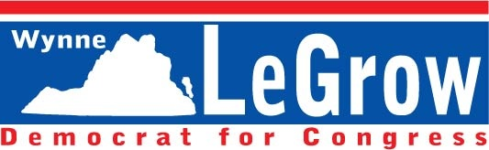

FOR IMMEDIATE RELEASE: Contact:

Evan Feinman

Deputy Campaign Manager

(434) 590-8522

efeinman@gmail.com

RANDY FORBES CONTINUES TO DUCK DEBATE, REPORTERS,

AND HIS CONSTITUENTS

VIRGINIA – A few days back, The Tidewater News ran an editorial that we at the Wynne LeGrow campaign found to be of great interest. After first noting that the paper’s long-beloved incumbent Randy Forbes is a swell and honest guy, the editors go on to raise a minor but noteworthy concern regarding a mysterious decision on Forbes’ part, made all the more mysterious by the congressman’s perceived virtues:

“Curiously, though, Forbes was unresponsive to an invitation by the Virginia Peninsula League of Women Voters to take on LeGrow in a debate. He’s also been unresponsive to our newspaper’s attempt to find out why he shunned the debate invitation. That’s unusual for Forbes, a straight-up guy whose re-election bids we have endorsed over the years.”

We would respectfully submit that a longtime politician who refuses to debate his opponent and who ignores questions submitted to him by a friendly newspaper is probably not a “straight-up guy” at all, but rather a crooked one who would prefer that the voters not have a chance to compare their candidates side-by-side lest they conclude that it’s time to send a better, more competent representative to Washington. If Forbes wanted the voters to be better-informed on how his policies differ from his opponent, he would happily agree to a debate. The fact that he refused not only to take part in such a debate but also to explain this unusual decision to his supporters among public and press alike should alarm anyone who believes that a representative should be answerable to his constituents. Forbes’ disregard for those who have elected him is itself an answer; he wants your vote, not your input.

However much the people and press might like Forbes to face LeGrow for a frank discussion about how to bring jobs back to Virginia, reduce the budget deficit, and ensure that the U.S. stays competitive amid a fast-changing international landscape, such a debate will almost certainly not come to pass. Luckily, we have come up with a partial solution, one which we think will be even more informative to the voters than a debate would have been.

Tomorrow, the LeGrow campaign will ask Forbes a question. This question will appear on our website, www.LeGrowForUSCongress.com, and will likewise be sent to every media outlet catering to the 4th district, as well as to the Forbes campaign itself. The day after tomorrow, we will ask another question, which will again appear on our website and again be sent to all of the parties noted above. The day after that, we will do the same thing. Likewise for the day after that one. We will, in fact, be asking a question each day, right up until the eve of the election next month.