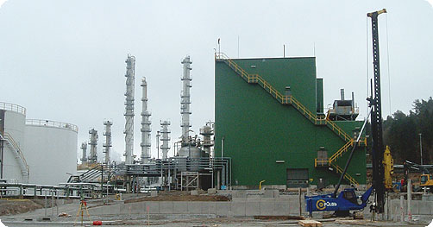

**From: Mrs. Maria Stephen puti**

**Ben puti (Son)**

**Phone: +27-739711178**

**No, 34 TOM SMITH Road Johannesburg**

**South Africa.**

**Dear Sir/Madam,**

**URGENT FAMILY ASSISTANCE:**

 With due respect, trust and humility, I write to you this proposal, which I believe would be of great interest to you. I found your contact while I was doing a private research in the Internet for a reliable and capable foreign partner that will assist my family and I to transfer fund to any personal or private account and for investment purpose. I am Mrs. Maria Stephen Puti, the wife of Late Mr. Hummel Puti, who was the "Chairman" of the farmer’s co-operation in Zimbabwe.   
  
My Husband was among the few blacks that were murdered in cold blood by the President Robert Mugabe Administration during the land dispute that just happened in Zimbabwe. After the death of my Husband, we decided to move out of Zimbabwe because our lives were in danger because of the money that my Husband kept in his hidden safe in our house. The amount contained in the safe is (US$9.5 MILLION) Nine Million Five Hundred Thousand Dollar.

 This money was meant for the purchase of a new machines and chemicals for the farms and establishment of new farms in Swaziland. Before his death, He was a Major Share Holder of companies in Zimbabwe. After my Husband died, we moved to South Africa and deposited this money in a security company in a box as valuables belonging to our foreign partner pending when we see somebody that will assist us transfer this fund to any oversea account and for the safety of our family.   
  
We are presently in South Africa as Refugee (Asylum Seekers) and as such, the law of South Africa does not permit us to operate or open any bank account here in South Africa or to be involved in any financial transaction with the bank. That is why we contacted you to assist us in this transaction.   
  
We are ready to compensate you with 25% of the total fund for your assistance. Contact my son Mr. Ben Puti on the above telephone number: 27-**739711178** indicating your interest to assist us. On receiving your acceptance, I shall be glad to give you more clarification on the modalities needed for smooth successful completion of this transaction.

 Attached to this mail is my husband’s company in Zimbabwe

 I anticipate your quick response.

Best regard.

Mrs. Maria Stephen

(For The Family)