Approach paper for HIN Race for Android and Java mobile environment
The Game will be developed on a platform which will provide cross-Social Network Integration and marketing.

Game Vision
- To provide a game on the mobile platform to engage and retain users
- Provide loyalty tools through the game for extending relationship
- Monetize the user engagement through rewards

Target audience
Demography
- Predominantly Male, 18 years +
- Mobile users
- English/ Spanish speaking
Geography
- USA, UK

Monetization
- Mobile Ads
- Virtual Goods and Virtual Money
- Paid Downloads
- Targeted Ads to users on Facebook and mobiles

Features
- Car Race on Android, Java App and Facebook
- Seamless persistence across Android and Facebook on Web. Users can continue playing across platforms with no break in play.
- 3D animation in Android and Facebook

Requirements

Social Deployment
Enabling developers to easily self-publish 3D games to multiple social networks.
- The Car race will have two modes :
- Single Player
- Multi Player

Venues

- 3 Racing venues will be provided in the beginning and a new venue added every quarter.

Pit Babes
- A Gallery of Pit-Babes will be provided to pick the racing team. The babes will join the pit-stop.

- Pit Babe Roles will be :
- Lollipop Babe
- The "Lollipop" - holds the team's pit sign, helping the driver identify his pit stall on a possibly crowded pit road. During the stop,
- She holds the sign in position to remind the driver to keep his brakes on while tires are being changed,
- She reminds to put the car in first gear once the jacks are lowered
- She also gives the driver the sign to depart his pit stall by raising the sign from in front of the driver.

- Crew Chief Babe 
- Leader of the pit crew.
- Fills the car with gasoline with a special gas can
- She will be the main model for the team

- Jack Babe
- Use simple Lever-type jacks to lift the car and permit the changing of tires.

- Pit Crew - 4

- One at each corner of the car, have the sole responsibility of carrying a tire and using a pneumatic wrench to remove the car's single locking lug nut from each tire, then reinstall it on the new tire.
- The Tire changers will be provided by default.


The Lollipop, Chief Crew and Jack girl will have to be earned through redemption of points. The User will have to select a Babe from the Model Gallery by paying Virtual Cash.

Cars
Four models of Muscle cars will included at launch. 3D models of up to 16 views mages are to be created and deployed for the purposes. Audio will be available in Mono or Stereo. Options are:
Chevrolet Comaro   | Ford Mustang  
Mitsubishi Evo   | Ferrari Enzo  

Playing Modes

Single Player mode
- User and one Artificial Intelligence player
- User may select a Car of his choice from the catalog
- User may customize the car from catalog of accessories. User will have to trade points for virtual currency to buy accessories
- Offline playing
- User may have option of using tutorials when playing in this mode.
- User may download the game to the mobile and play the game offline, posting score scores to Facebook.
- Five levels of games in Single payer mode, with increasing challenges
- Tutorials and Suggested moves as pop-up
- Share on Facebook
  - Once the user completes the first level, user should be prompted to share the information with all the friends and users of the game.
  - After the successful completion of each level by the user, the score/points would be displayed and should ask for the complements.

Multi player mode
- Player to player (Invite a friend as player)
- User plays against his friends on mobile using Bluetooth or broadband.
- User has the option of downloading the game to the mobile to play the game.
- Users can post their scores on Facebook, inviting or challenging friends.
- Players may play in synchronous or asynchronous (offline) modes.
- Online playing
  - User of the game should be given an uninterrupted service.
  - Application should be monitored at each level for the particular users and should share the information to all the users in the social network.
- Share on Facebook
  - Share wins and challenges on Facebook with friends

Common Features
- Real time shadows
- Language support and Localization
  - Language : English
  - Geography : USA, UK
  - Other languages and Content to be provided by customer
- Localization based on User location determined by
  - User preferences
  - GPS location
- Accelerometer and GPS integration
  - Use can turn on Accelerometer for Navigation and control
  - User may use GPS navigation to chart a route

Cross platform Persistence
The game will provide seamless continuity across Android and Facebook on web. Data services that continually track user progress and automatically saves crucial game information.
- Users level of progress in the game and users score are to be stored in the data base automatically.
- According to the scores of the users, application will offer for the virtual item purchase, so that user purchases the item or make more points.
- When user leaves the game or connection drops out, software should retain the users level of game and provides the continuity of the game, once the user logs in, irrespective of the user using a mobile or web.
- Persistent solution should be given to the user to pick up from where they left off , regardless of the browsers or if cookies has got cleared.
This has the advantage of extending user loyalty to the brand not just on the mobile but also on the web.

Mobile Advertising
Targeted in-game advertising that maximizes player exposure while minimizing interference using
- 360BuzzAds Ad Engine would profile the user based on his Facebook profile and determine the ad to be presented, considering the user’s demography, geography, present education/employer, Alumni (school, college & work )and likes ( movies, music, books, sports, arts & entertainment, activities & interests, etc.)
- Google AdMob integration will provide mobile Advertizing on PPC and PPM mode and therefore help in monetizing traffic.
- Game would be Real time so that maximizes player exposure.
- AD sponsored virtual items should be prompted for particular level of game and for the scored points.
- Delivered ad contents should be shared to all the users so that it appeals to the player interests.
- During the breaks users could be given an offer or rewarded with sponsored incentives and discounts on goods and services.

Game Helpdesk
A secure solution to upload, monitor and monetize virtual items.
- Build the characters and publish in the game website so that the developers can use it enhance and develop the game.
- Performance upgrades
- Character enhancements
- Power ups and health
- Unlocked content

Leaderboards
The ultimate score keeper to stimulate competition and connect players.
- Score keeper to connect players and keep track of all the users in the social network.
- Boards could be customized to suit the requirements of the car race style, Babes request, and race metrics such as point calculation, best lap time, referrals, virtual money earned, etc. .
- Board should display all the global and local (friends) scores.

Social Engagement
Easily manage game invites, item gifting, and publishing scores to player profiles.
- Users can send invites to friends with offers and challenges.
- Users and Friends can have the following features:
- Become a Fan
- Bookmark the App
- Publish to my stream
- Get *all* my friends
- Get my friends using the app
- Send Notifications
- Send Invites
- Send Requests
- Prompting for Publishing Permission (automatic, once per day)
- Post score to playing user’s wall
- Post story to the playing user’s wall.
- Post and award an achievement to the playing user’s social network feed.
- Trigger a display of the send request to multiple friends’ window.
- Send requests to the user’s friends.
- User will earn loyalty points for
Activity | Points earned
Friend Invites | 5
Friend Challenge | 10
Revisit | 10
Send Assistance request | 5
Accept to Assistance Request | 20
Severe accident | -20
Win a race | 100

Analytics
Detailed metric data to measure and improve monetization and user experience. Detailed analytics will include:

User Analytics
Demography, geography and Friends playing the game to determine circle of influence.
An ever-growing set of real-time analytics tools provide developers with the ability to analyze the game at both a macro and micro level. They will include:

Player engagement
- Behaviour patterns
- Ad visibility
- In-game purchases
Further analytics will be available from 360BuzzAds engine, Google Analytics and AdMob Analytics

Points and Rewards
A flexible system for adding customized Rewards.
Rewards system should be flexible and easy to use. Based on a gamer score, each game is allotted 1,000 points to create rewards. User will earns points by passing through Goodies such as Balloons, power-ups, etc. User will lose points for accidents, fuel burn, etc.

Single player format
Rewards are structured into different levels, such as:
- 1000 points –Lollipop Babe
- 2000 points – Jack Babe
- 3000 points – Chief Crew Babe
- 4000 points – New Pit Crew Babes
- 5000 points – Race winner, Golden Leader board ranking , entry to multi player
User can trade points earned for power-ups such as:
- Turbo charger
- Nitro booster
- Race Handicap
- Car upgrade
Power ups will help user to gain advantage on AI competitor.

Multiplayer format
Once the user has graduated beyond the Level 5, he will be eligible to play the Multi-player format and race against friends and other users.
The user can begin by choosing an avatar followed by inviting/challenging friends to race with him.
Users can then race against each other and win rewards and points. They can get additional boost by increasing Virality and Social interactions such as requesting friends for help. Each race will help in acquiring virtual cash/goods, irrespective of winning or losing.
Users can avail points as in the single player format.

Unity 3D
Support for the most powerful and affordable 3D browser engine.
API supports Unity: a fully-integrated multi-platform game development tool designed specifically to ease game creation.
Not only is Unity uniquely usable and extremely powerful, but it is also revolutionary in terms of bringing retail-quality gaming (3D graphics, Ageia PhysX, online multiplayer functionality, etc) to web browsers worldwide – currently the #1 game development tool for the iPhone

Pre-requisites

Scalable Hosting
Customer needs to provide Game hosting facilities. Game hosting engineered to keep pace with dynamic player growth, based on sizing. Hosting requirements will be provided once confirmation is given.

Other points
- Customer will provide The Game Rules
- Customer will provide references for Game UI
- Customers will provide handsets and compliance standards
- Customer will provide or facilitate content in multiple languages from pre-qualified vendors
- Customer will provide branding content
- Customer will provide orientation to the development team on the target handsets
- Customer will provide a dedicated resource to coordinate with the development team, as a single point of communication during the development lifecycle
- The Scope of this document covers only the development. The Post-release maintenance and support has not been factored and needs to be addressed.
- The customer will procure and provide any third party test and validation software required along with the necessary training if any.
- The customer will provide proprietary software, protocols and tools along with relevant training if any

Engine architecture
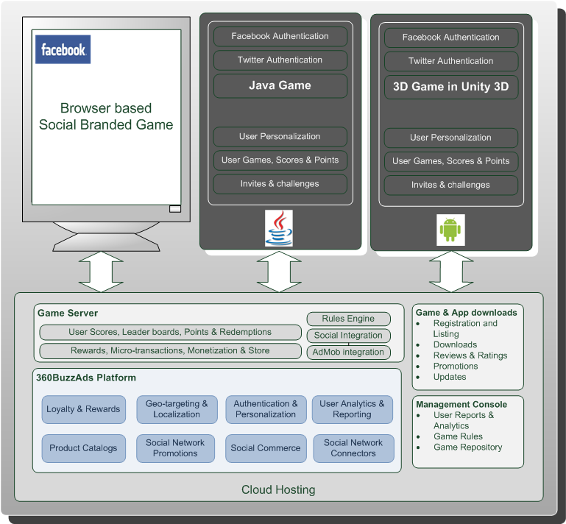

Game Development

Android platform using Unity 3d and ADK
The Game will be developed in Unity3D and deployed on Android and Facebook. Users can seamlessly play across both platforms, thereby getting maximum penetration across platforms. The customer may incentivize users for game play with gifts and vouchers.

Other platforms using Java
The Game will be developed in Unity3D and deployed on Android and Facebook. Users can seamlessly play across both platforms, thereby getting maximum penetration across platforms. The customer may incentivize users for game play with gifts and vouchers.

Server
- The Server will handle the unified user experience, personalization, Games, scores and points, redemptions, gratifications, etc
- The Server will manage geo-targeting, localization, Analytics and reporting, Promotions, and Social Network connections across, Facebook, Twitter, etc.
- Promotions and offerings will be categorized based on the mobile used by user.
- CRM Integration will provide the customer with a mechanism to handle Lead Generation, Promotions and issues with users, offline.
- MobiCoCo’s 360BuzzAds PAAS Server will be deployed and leveraged

Life cycle Process
MobiCoCo offers an iterative and incremental Life cycle model that is a combination of Best Practices from RUP and Agile Models, thereby delivering Controlled Product Development with Agility to handle Change and Rapid response.
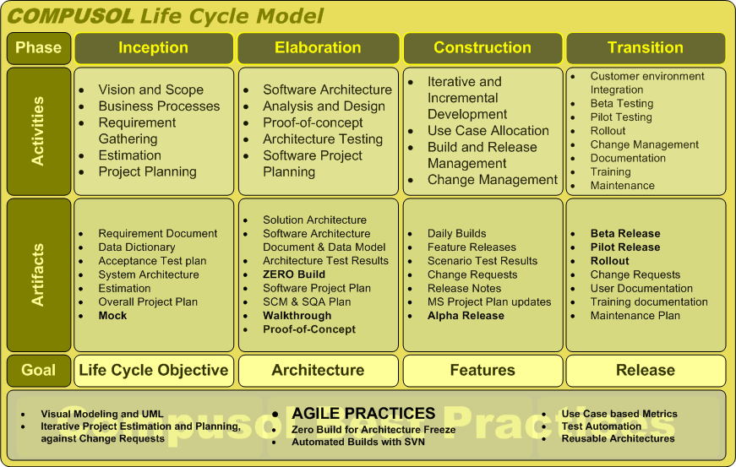

Inception Phase
Objective: Requirements and Planning
- The Overall scope of the game to be firmed up with detailed requirements and Overall Test Plans. The Overall project plan, Resources, Schedules and estimations will be drawn up.
- Mocks will be presented and approvals sought for graphic content and layout
- Typical elapsed time : 4 Weeks

Elaboration Phase
Objective: Architecture and Design Freeze
- The Software Architecture, Analysis and Design will be completed.
- A Zero Build, with the architecture tested and frozen is versioned. The Zero build is frozen after completing a Proof-of-concepts, external interfaces and performance considerations.
- Detailed Test Plans and Cases with target platforms and handsets identified
- A Software Project Plan details Use Case based Iterative and incremental plan for development and Periodic Release
- Target Test environment set up
- Game Walkthroughs on target handsets
- Typical elapsed time : 4-6 Weeks

Construction Phase
Objectives: Feature Construction
- Use Cases allotment to development team for iterative and incremental delivery of product
- Daily Builds and Periodic Release of Product on Target Test environments
- Iterative and Incremental Releases
- Testing, Bug reporting and Change Management
- Issue management
- Setup User environment
- Content Localization
- Alpha Release : Feature Completions release to Test environments
- Beta Release for Testing
- Typical elapsed time : 4 months

Transition
Objective: Testing and GTM
- Beta Testing on User Environment
- Issue Management
- Iterative Releases for closures
- User Documentation and Support setup
- Pilot testing with sample user base
- Issue Management and Resolutions
- Content clean up and Localization
- GTM Release
- Typical elapsed time : 4-6 Weeks

Maintenance
Subsequent to the deployment and roll out of the Game, a maintenance team will take over and provide upgrades and enhancements to the game by way of Babes, Cars and Venues. Further the team may require to localize the content into other languages and geographies.

Project Plan
The Project plan is tentative, based on available information and will be revised once complete requirements and game rules are available.

Team composition
Role | Qty
Producer/Project Manager | 1
Game Designer | 1
Creative Artists | 1
Dev Lead | 1
Developers | 2
QA | 1
Content manager ( shared resource) | 1
Total Team Size | 8

Effort
Phase | Effort in man months
Inception | 5
Elaboration* | 5
Construction* | 28
Transition* | 10
Total | 53
Third-party effort, such as translation, is not included in the effort estimation

Maintenance
Resources | Qty
Development | 2
Testing | 1
Content | 1
Project Management | 1
Total | 5

Schedule
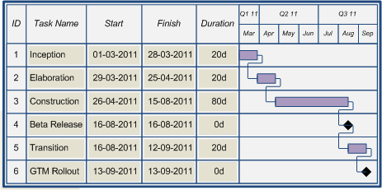

Development Cost
Rate | USD 2630 per man month
Effort | 53 man month
Budgeted Cost | USD 139,390.00

Maintenance Cost per month: for the Facebook game, where on an average 2 new features will be added every month and day to day maintenance for the user and advertisers.
Total resources required | 5
Rate in USD per resource-month | 2050
Amount per month | 10250

Next Steps
- The customer is requested to provide a checklist for prequalification
- The customer is requested to provide roadmap and steps for engagement
- The customer will need to provide engagement model
- The customer will need to provide Review mechanisms and plans
- The Customer needs to provide information on any process lag or wait times during development

