**Attack on Amn al Dawlah HQs in Egypt.**

**12 April 11**

**Nick Fielding**

ON 5th-6th March thousands of protesters seized control of the Egyptian Security Force’s headquarters in a number of cities throughout the country, including Alexandria, Cairo, Nasr City and Lazoghly.

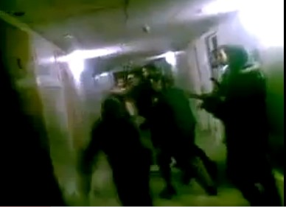

The protesters were able to collect thousands of files from the buildings of *Mabahith Amn al Dawlah*, the State Security Investigations Service, including information on prisoner torture, corruption and many other subjects. The raids occurred after the collapse of the Mubarak regime, but while the old regime’s security services were still intact. Since the looting of the buildings the Egyptian authorities have ordered the arrest of 47 state security officers who are accused of burning documents. The head of the organisation has also been arrested under suspicion of ordering the killing of civilians. On 15 March the Ministry of the Interior announced the dissolution of the agency.



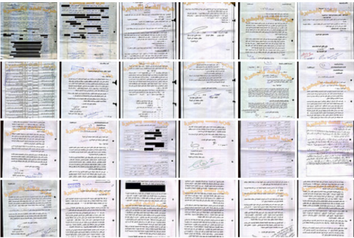

In some places the raids took place because protesters noticed that smoke was coming from the Amn el-Dawlah buildings and realised that documents were being shredded and burned. In fact, amongst the documents was one (see below) which appears to have been a plan by the security services to destroy its archives of hundreds of thousands of documents. It contains instructions for the abolition of all branches of the archive branch offices and destruction of their content by shredding.

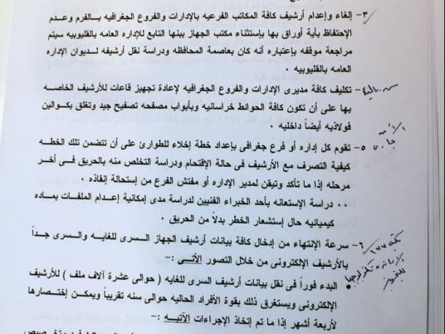

One document revealed that the number of personal files in the archives totalled 354,000. It is thought that Amn al Dawlah employed up to 100,000 people and had the role of controlling opposition groups, both armed and unarmed. In the past Human Rights Watch had singled out the organisation for what it called a “pervasive culture of impunity” with regard to torture.

The documents recovered concerned such issues as relations with Algeria, torture, election fraud, under-the-table deals with media, politicians and international governments, the attack on the Kadesin Church in Alexandria, companies that supplied Amn el-Dawlah, offshore accounts of the Mubarak family. There were also sexually explicit tapes of many public figures, as well as implements of torture and secret prison cells.

Some purported to show that the July 2005 bombing of the Movenpick hotel in the Red Sea resort of Sharm el-Sheikh in which 88 people died, was carried out at the behest of the Mubarak regime. Previously it had been blamed on either Bedouins or Islamists.

One document describes how three car bombs were to be detonated in or around the hotel, which was owned by businessman Hussein Salem. The bombing was allegedly ordered by Gamal Mubarak, one of the president’s sons, and former head of the Interior Ministry Habib el-Adly – who has since been indicted. The reason was a gas deal with Israel. According to the documents, Mubarak wanted revenge on Hussein Salem because he had ‘triggered’ a reduction in commission for the deal from 10 percent to five percent.

Another document shows that the bombing of a Coptic church in Alexandria on 31 December 2010 was carried out by state security operatives in order to sow dissent and discourage Copts from taking part in protests against the regime.

Since the dissolution of Amn al-Dawlah, the new Interior Minister Mansour el-Issawy has announced plans for the establishment of a new National Security Sector to take over the role of the discredited organisation in counter-terrorism and other domestic security operations.

ends