UNITED KINGDOM UNIVERSAL LOTTERY INC.,.

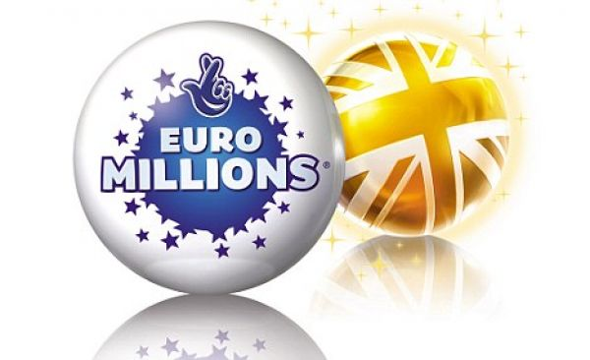
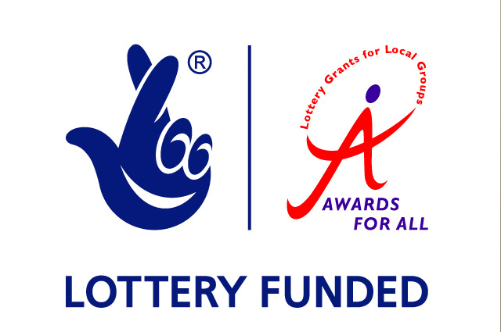
UK UNIVERSAL LOTTERY INC.
THE LOTTERY HOUSE
LONDON
SW1A 2JL
UNITED KINGDOM
(Customer Care Unit)
Date: 8th May, 2011
Ref: SGIL: 763276/03
Batch: 6858/UK
Dear Winner No: 7.
BONUS

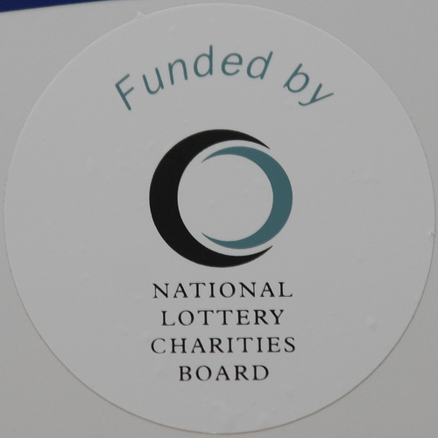
We are pleased to inform you of the announcement today, 8th May, 2011 winners of The United Kingdom Universal Annual Lottery Award, conducted on the 1st January, 2011. Your email address attached to ticket number 023-56678230954, drew the lucky numbers 06-09-11-33-36-49-29, batch number 6858/UK and consequently won the lottery in the 3RD category. We are apologize for the delay in the release of the results which was caused by our computer system Breakdown which resulted in a mix up of some name and addresses of beneffficiaries and participants. As a security protocol to avoid fraudulent claims we ask you to keep your Award notification letter out of public until your claim has been processed and your winning cheque remitted to your designated bank account. You have therefore been approved of a lump sum pay of £1,500, 000, 00 (One Million Five Hundred Thousand Pounds Sterling) which has been credited to file REF NO. SGIL/763276/03.

This is from the total prize money of £278, 000, 000, 00 which is to be shared among the forty International winners in categories C with serial number: IL/FLW/12-C033721192. All participants in this lottery program were selected randomly through a computer ballot system, drawn from 85.000.000 individual email addresses from all search engines. Your e-mail address was picked by the automated computer ballot system, which has been programmed for this random selection. This has eventually qualified you for the Winning. This promotional program takes place annually, and is promoted and sponsored by eminent personalities, Sultan of Brunei, Bill Gates of Microsoft Inc. With the support of European / African corporate companies and organizations to encourage the use of Internet in different parts of the world.

Note that your lucky winning ticket file and number falls within our European booklet representative office in London (UK) as indicated in your ballot played coupon. In view of this, your £1, 500,000.00 would be released to you by our payment department. Contact our Foreign Service Manager immediately to commence release of your lottery prize by providing details below.

United Kingdom Universal Lottery FSM
Edward Middleton (PhD)

Address:

TP/UKUL INC HQ, Room 427, Victoria Embankment, Westminster, London SW1A 2JL.

+44 (0) 703 598 6900


uklcenter@excite.co.uk
ukcenter1@hotmail.com

For security reasons, you are advised to keep your winning information out of public till your claim is processed and your money remitted to you in whatever choice you want to claim your prize. Precautionary measure to avoid double claiming and unwarranted abuse of this program are in place. Please be warned!!! To file for your claim, contact our Foreign Service Manager and provide them with your winning email and details.

THE FUND RELEASE VERIFICATION FORM

1) APPLICANT’S NAME:

2) CONTACT ADDRESS:

3) MOBILE PHONE NUMBER:

4) FAX NUMBER:

5) YOUR PERSONAL E-MAIL ID:

6) OCCUPATION:
7) AGE:

8) SEX:

9) MARITAL STATUS:

10) RELIGION:

11) NATIONALITY:

12) STATE:

13) COUNTRY:

14) THE AMOUNT WON:

15) DATE OF DRAW:

Be aware that our Paying Authority will Effect Payment Swiftly upon satisfactory Report, Verifications and validation provided by our paying bank. Note: According to lottery code of conduct section 37.2 page 10 paragraph 5, All winnings must be Claimed not later than 30 days from the date of this notification; thereafter all funds will be returned to the Ministry of Finance Britain as unclaimed please remember to quote your reference number in all your correspondence and should there be any change in your contact addresses, do contact the Foreign Service Manager immediately. Forward to Edward Middleton’s office the above details for the transfer of your won prize.

Important Warning: You are expected to keep information relating to your award out of public until payment is processed and received, this is to avoid having your mailbox hacked by any of the persons to whom you disclosed it and using the information obtained to attempt to impersonate you and to fraudulently collect your cshd price.Contoversial claim will lead to disqualification. Be warned!.

Congratulations once again from our staff and thank you for being part of our promotional program.

Yours Faithfully.




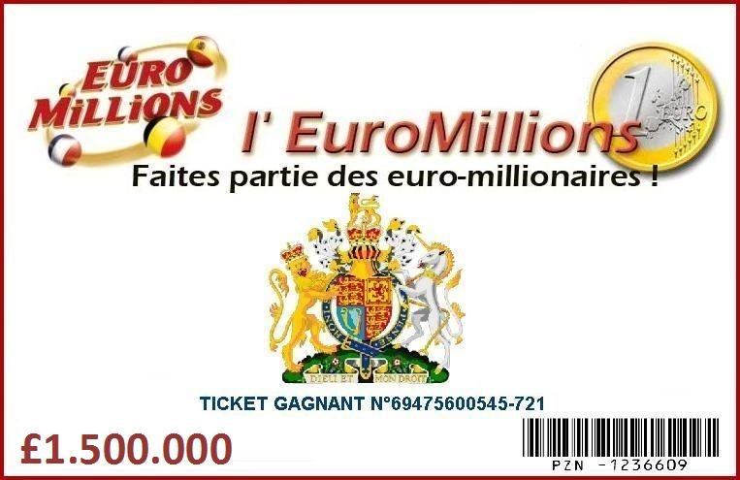

Dmitriy Nikolayw (Mrs.) (Lottery Coordinator)
Online coordinator for THE UNIVERSAL LOTTERY.

Copyright © 1990-2011 The UKUL Online Lottery Inc.
All rights reserved. Terms of Service - Guidelines

77635 476378 355677461

