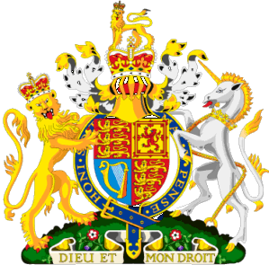

Dear E-mail User,

Your email has just won the sum of £700.000.00 GBP in cash credited to a file in the just concluded MICROSOFT NEW YEAR AWARD PROMO held on Draw Date: Monday 16/01/2011. You were selected among the lucky recipients to receive the Grand sum of Seven Hundred Thousand Great Britain pounds sterling in cash credited to fill ktu/9023118308/03 approved by British Government held in London, United Kingdom.
====================================
Winning Numbers: 13, 27, 28,74,65,45 bonus 11.
Ticket Number: ktu/7657765239/00
Secret No: 335429/40
Winning Date: Draw Date: : Monday 16s/01/2011
======================================
Be informed that a cheque has been issued in favor of your name as the lucky beneficiary and also your winning cheque has also been handed over to the City Link Courier Service Ltd, to make delivery to your address. At this point you are advice to contact our authorized Company to enable them commences with the delivery immediately.

CONTACT INFORMATION.
E-mail: citylinkcourierservices02@live.com
Name: Mr. Books Williams
Tell:+447017602403
(1) NAME:
(2) ADDRESS:
(3) MOBILE NUMBER:
(4) DATE OF BIRTH:
(5) SEX:
(6) OCCUPATION:
(7) COUNTRY:
(8) STATE:


Sincerely,
SIR HENRY BERNARD.

