Breitbart's Weiner hoax: New photos surface! Analysis, and Surprise! (UPDATED)
byTBTM Julie

I apologize for yet one more diary on this subject, but I have a lot of information and photos - too much for a comment. I've been puzzling this out for days, asking questions as new information appears.

Last night, @patriotusa76 claimed to recover a photo from his browser cache, with the help of @joebrooks. About 12 hours later, @patriotusa76 claimed to have found the full size 800 x 600 image in his cache as well.

Upon examination of these images, it is my opinion they show @patriotusa76 is at minimum, a co-conspirator in a hoax, if not the person who inserted the photo into @RepWeiner's yfrog feed.

I'm going to add to this diary throughout today, but here are couple images to start:

Here is the information from a photo known to be taken from @RepWeiner's Blackberry. Notice the file information, where it came from, and the device information:

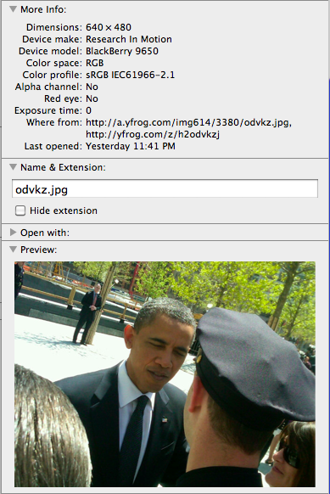

@patriotusa76 claims he found two versions of the lewd photo in his browser cache belonging to @RepWeiner. There is no doubt something was posted to Weiner's yfrog account, and after talking to multiple folks both liberal and conservative, they all claim to have witnessed this picture on Weiner's yfrog account.

This is a side by side comparison of the two photos @patriotusa76 sent, claiming they were found in his internet cache:

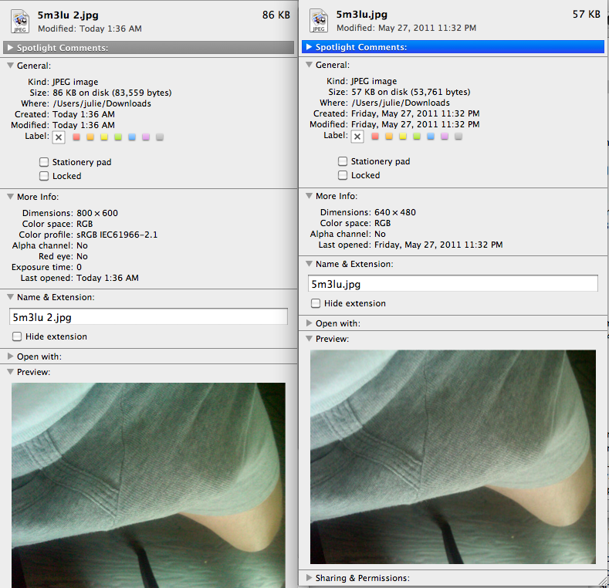

Compare the Exif data between all the photos. While the one shot is clearly from the 27th, the 800 x 600 appears to have been created early this morning and the Exif headers edited. Additionally, the file names are not consistent with yfrog: when you view larger files in yfrog, the actual picture name tends to be shorter.

Now the question to ask: why doesn't the original cache file @patriotusa76 is presenting have the yfrog information attached?

Or did @patriotusa76 just send the smoking gun showing he had an original copy of the file which either he posted to @RepWeiner's account, or was emailed to him by someone else who had posted it to his account?

And if you're wondering how easy it is to edit Exif info, take a look at this:

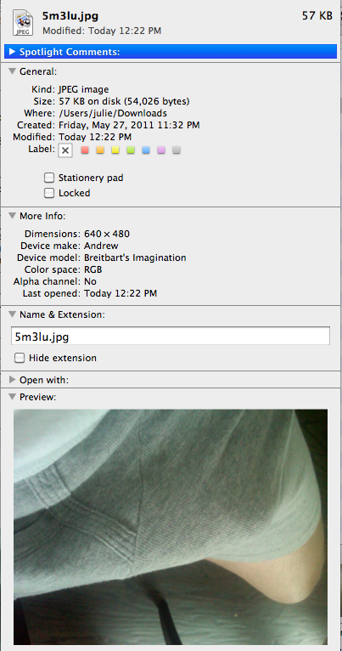

Update: Next up: Screenshots and timeframes, odd inconsistencies

Before these photos showed up, Big Journalism had posted the account of what they saw (who is P.J. Salvatore anyway? appears to be a fake person):

http://bigjournalism.com/...

I downloaded the images from this site, and based on their filenames, tried to construct a timeline.

Here is a screenshot of the tweet as posted on Big Journalism:



The filename is: RV-AC955_MAMET__G_20110527012057-copy.jpg

Breaking down the filename, you get the timestamp: 2011-05-27 01:20:57. If the tweet was 2 hours, 18 minutes old, if I'm calculating correctly, that means it was tweeted at 11:02 pm EST.

The more interesting thing is the screenshot posted that was analyzed by Eileen B:



Looking at this filename, this screenshot was taken on a Macintosh. I asked @patriotusa76 if these were his screenshots, and he said they were not. @joebrooks talked about walking him through recovering cache photos from IE8, so it's clear he's on a PC.

But once again, take a look at the date in the filename: Screen-shot-2011-05-27-at-110409-PM.png

Calculating from this, if the photo was posted to the yfrog account 27 minutes, 28 seconds ago, then that would mean it was posted at 10:36 pm EST and that the postings to yfrog and Twitter were not simultaneous.

@patriotusa76s retweet was almost instant - two minutes later at 11:04 pm -after the @RepWeiner account tweet.

Now, here is where it gets interesting:

If the yfrog was posted at 10:36 pm,
and the Twitter was posted at 11:02 pm,
why would @patriotusa76's cache file be set to 11:32 pm and not sometime around 11:02?

Is it possible he uploaded the file to the yfrog account around 10:36 pm and later changed the timestamp to 11:32 as to not look suspicious?

