Congressman Anthony Weiner Twitter Intrusion

Congressman Anthony Weiner of New York District 9 lost control of his Twitter userid and this became publicly apparent on May 27th around 1:00 AM eastern. A suggestive photo of a partially erect male, seen from the waist down and clad in briefs, appeared on a yfrog photo account associated with the Congressman’s Twitter ID. The link to this image was sent in a public tweet directed at Genette Nicole Cordova, a 21 year old college student residing in Seattle, Washington.

The Congressman quickly regained control of his userid and publicly announced that he had been hacked. The manner in which the image was created and distributed have been a source of much discussion and analysis. We suspect that it will be a simple exercise to pin down exactly who did the intrusion, despite the normal difficulties in dealing with a case like this. We also find that there is a good possibility that this act involved persons already known to have invaded the privacy of elected officials.
The following Twitter IDs were directly involved in the event:

http://twitter.com/RepWeiner - Congressman Anthony Weiner’s official account.

http://twitter.com/GenetteNicole - Genette Nicole Cordova, age 21, resident of Seattle, Washington, and recipient of the public tweet containing the link to the off color image.

http://twitter.com/patriotusa76 - a Twitter account associated with the name “Dan Wolfe”. This account ‘discovered’ the tweet, its attendant image, and then set about promoting this discovery.

http://twitter.com/DLoesch - Dana Loesch, PJTV commentator & Big Government editor. This is the first right wing media figure whom patriotusa76 approached.

http://twitter.com/goatsred - real name unknown, seems to have been guiding patriotusa76

The following are associates of Dana Loesch and Andrew Breitbart of http://biggovernment.com.

http://twitter.com/AndrewBreitbart - owner of Big Government web site, facilitator of various schemes involving illegally obtained or fraudulently edited materials. A serial fabricator of ‘news’.

http://twitter.com/JamesOKeefeIII - serial fabricator, tapped Senator Mary Landrieu’s phones, multiple instances of covert taping in violation of state statutes on both east and west coast, and otherwise involved in things likely covered by U.S. Code Title 18.

O’Keefe’s accomplices on the Landrieu phone tapping were Stan Dai, Robert Flanagan, and Joseph Basel. Basel maintains http://twitter.com/JoeBasel but it has issued just one tweet in the last six or eight months.

O’Keefe was involved in illegal covert taping of persons working for ACORN in conjunction with Hannah M. Giles. Miss Giles owns but has never used http://twitter.com/HannahMGiles

O’Keefe and others conspired to ‘punk’ CNN reporter Abbie Boudreau. This appears to us to have been an aborted drugging/date rape attempt. The planner for this event was Benjamin Wetmore, who owns but rarely operates http://twitter.com/BenWetmore

O’Keefe operates an ‘investigative journalism’ operation known as Project Veritas. His accomplices in ‘journalism’ are http://twitter.com/Shaughn_A, Shaughn Adeleye, which seems to be an alias for Amir Malik, and http://twitter.com/simontemplarpv, Simon Templar, which seems to be an alias for Omar/Ibrahim Kassam. Both of these userids have been busily promoting the smear and attempting to ‘investigate’ Ms. Cordova.
The patriotusa76 account was involved with a parody account http://twitter.com/RepNeedleDick. Things sometimes disappear from Twitter, necessitating a burdensome subpoena & dig through records, so we captured the entire timeline from this account and stored it, as well as patriot76 and goatsred.

http://www.scribd.com/doc/56621592/Rep-Needle-Dick

http://www.scribd.com/doc/56678261/patriotusa76-tweets-april26-may30

http://www.scribd.com/doc/56688842/Goatsred-Timeline

An inspection of RepNeedleDick’s conduct, its interaction with Congressman Weiner, and with patriotusa76 make clear that someone spent the prior six weeks sizing up the situation around the Congressman’s account and his followers before they acted. This tweet from patriotusa76 on 5/11/2011 seems to foretell the intrusion, as well as the underlying motive – payback for the drubbing that conservatives just took in New York 26.

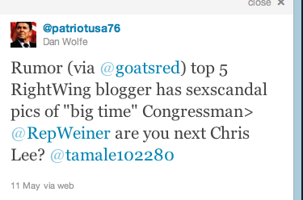


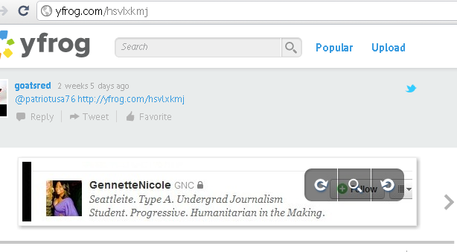

Here we see @goatsred pointing out the young woman, Genette Nicole Cordova, who was later the subject of their attention.
We would expect Dana Loesch to be in the know with a scheme like this given her membership in the leadership of Big Government. She admits having screen shots in this capture.

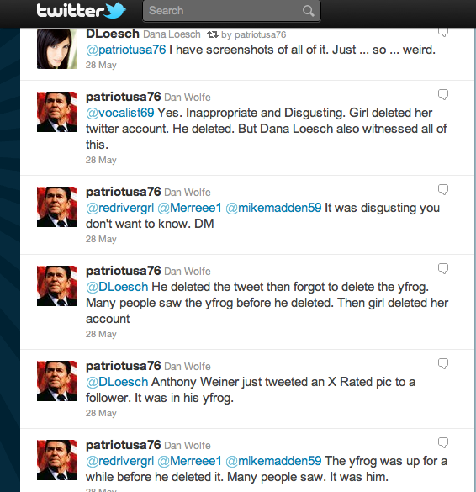

Andrew Breitbart has funded and directed things like this intrusion in the past, most notably the destruction of ACORN. He wasted no time in taking this sketchy smear and running with it.

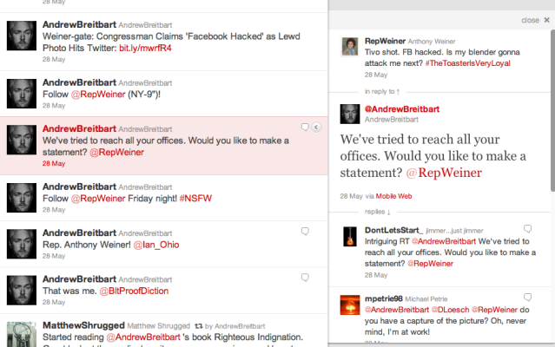
We have attached an analysis from a blogger familiar with image editing. She has provided a detailed write up with time line and a description of the technology and her conclusions regarding the handling of the alleged photo.

The outstanding issues we’re still pursuing are:

- We only covered four accounts immediately involved with the event and the historical background of Breitbart and his associates. There is information in the timelines of patriotusa76, RepNeedleDick, and goatsred that will yield another dozen accounts that require inspection.
- The examination thus far only covers the surface – Twitter IDs. A deep dive into real identities is already being done by various trolls, we need to get into this before the involved parties are scattered by thrill seekers.
- There are sources that the FBI would not have the skill (must be a local) or the time to cultivate that will respond to us. We’ll see what else we can learn.

