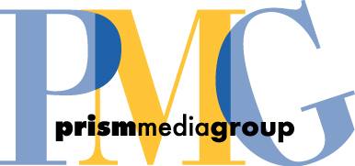

This work-for-hire agreement is made the 25th day of July 2008, (“Effective Date”) by and between Barrett Brown (“CONTRIBUTOR”) and PRISM Media Group (“PMG”).

1. CONTRIBUTOR and PMG hereby agree to the following terms and conditions for all works submitted to PMG for publication both before, if any, and following the Effective Date (the “Work”).

2. CONTRIBUTOR assigns to PMG ownership of all right, title and interest in and to the Work, and its derivatives, including ownership of the entire copyright in the Work. CONTRIBUTOR also agrees to execute all papers necessary for PMG to perfect our ownership of the entire copyright in the Work. CONTRIBUTOR represents and warrants that the Work will be original, and will not have been previously assigned, licensed or otherwise encumbered.
3. CONTRIBUTOR warrants that he or she is the sole author of the Work and has full power and authority to make this agreement. CONTRIBUTOR shall act as an independent contractor and not as an employee or representative of Company. CONTRIBUTOR shall not be entitled to any benefits, including workers compensation benefits, accorded to PMG employees, or to participate in or receive any benefit under any benefit plan or program PMG provides to PMG employees.
4. Following the Effective Date, PMG shall pay CONTRIBUTOR for CONTRIBUTOR’s services and the rights granted herein in accordance with the mutually agreed upon fees, if any.
5. This agreement shall be construed and interpreted according to the laws of the State of Texas without respect to its conflicts of law provisions and shall be binding upon the parties hereto, their heirs, successors, assigns and personal representatives. All references to the CONTRIBUTOR and to PMG shall include their heirs, successors, assigns and personal representatives.

Accepted and agreed:

CONTRIBUTOR PMG
_______________________ 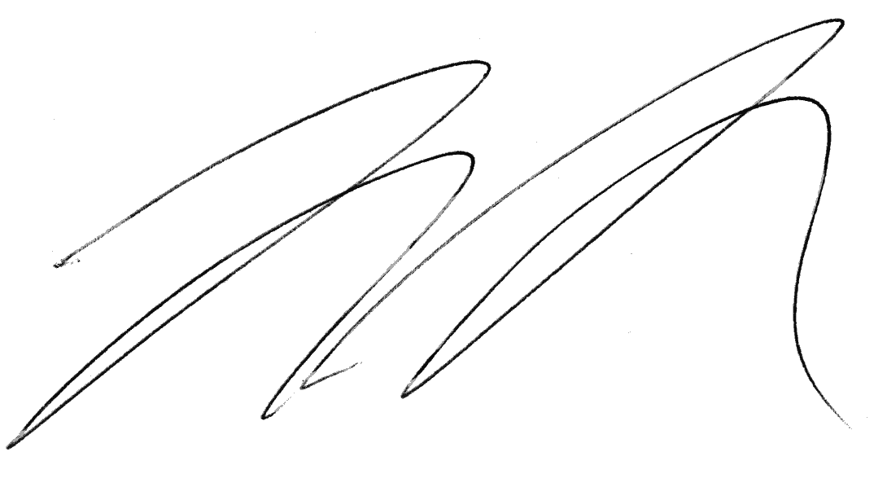
Signature Signature

_______________________ Mario Medina
Date Printed Name

_______________________
Printed Name

