DIETARY INFORMATION FORM:
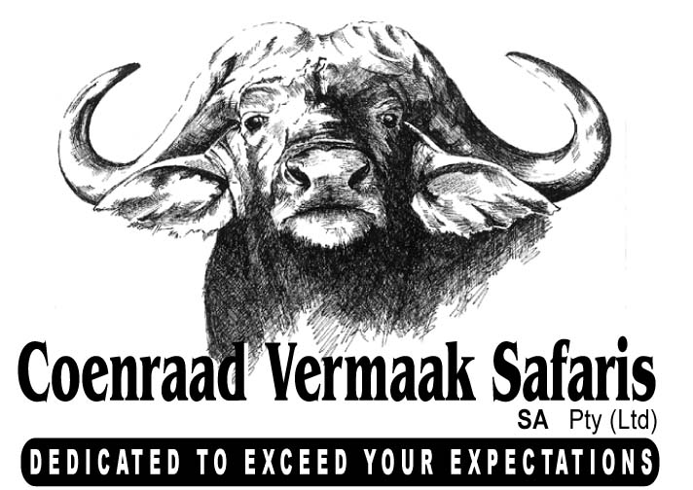
Please complete and fax or e-mail back to: +27 33 3431993 or admin@cvsafaris.co.za

NAME: | Barrett Brown

(1)CATERING AND DIETARY INFORMATION:
During your safari, your caterer will prepare a variety of wholesome dishes, salads, fresh vegetables and the like. Please bear in mind that our caterers are working in remote areas so the pre-safari catering has to be planned very carefully prior to your safari. Please provide us with any dietary preferences that may assist your caterer in planning your safari menu accurately.
Breakfast: As the hunting day starts early we have found our guests prefer a light breakfast to be served. This would include cereals, fresh muffins, toast & jellies / jams, fresh fruit and yoghurt etc.
Mid Morning: A cool box of refreshments, coffee or tea and sandwiches & fruit is taken on the hunting vehicle to be enjoyed out in the field.
Brunch / Lunch: Upon your return from your morning hunt (around 12:30pm), you will be served a hearty meal comprising for example, spaghetti bolognaise or macaroni cheese with fresh green salad and home made breat, other savoury dishes like chicken or venison bakes or a fry up of bacon and eggs, or cold meats and salad etc. This is normally followed by a well deserved afternoon nap! Depending on what you are hunting, you may at times, not return to camp for lunch in which case a picnic basket will be made up for you.
Pre-Dinner snacks / Cocktails: After your afternoon hunt, snacks and drinks are served around the campfire prior to dinner.
Dinner: Your caterer will serve a variety of beef, chicken or lamb dishes, for example Roast Beef or Steaks, various Venison dishes, traditional “potjies” (stews cooked over the fire in traditional Zulu black pots) and of course the traditional South Africa “braai” (barbeque). All dishes are served with fresh vegetables including broccoli, cauliflower, various squashes, peas, green beans, potato, rice and others. This is always followed by dessert!

ARE THERE ANY FOODS (including desserts) YOU DISLIKE OR DON’T EAT (Allergies etc), PLEASE SPECIFY BELOW:
None

(2)REFRESHEMTNS – SOFT DRINKS & LIQUOR:
Please indicate your preferences from the list below. If you have a preference for any drinks / labels, other than those listed, please specify these below so we can purchase these, along with your other choices, in advance of your arrival, or you can do so with your Professional Hunter or Safari Representative who meets you at the airport upon your arrival. Please bear in mind that South African suppliers will not always stock foreign labels. Liquor is for your personal account and is charged at cost price.
SPIRITS |  |  | BEER & WINE |  |  | SOFT DRINKS / MIXES |  |  | WATER / JUICES
 | Bourbon – Jack Daniels |  |  | Beer – Hansa Pilsner |  |  | Coke |  |  | Various Fruit Juices
 | Cane Spirit – Mainstay |  |  | Beer – Castle Lager |  |  | Coke Lite |  |  | Still Water
 | Gin – Gordon’s |  |  | Red Wine (variety) |  |  | Lemonade / Sprite |  |  | Sparkling Water
 | Whiskey – Famous Grouse |  |  | White Wine:  - Dry  - Off Dry  - Semi-Sweet |  |  | Ginger Ale
 | Brandy – Klipdrift |  |  | White Wine:  - Dry  - Off Dry  - Semi-Sweet |  |  | Dry Lemon
 | Vodka – Absolut |  |  | White Wine:  - Dry  - Off Dry  - Semi-Sweet |  |  | Soda Water
 |  |  |  | White Wine:  - Dry  - Off Dry  - Semi-Sweet |  |  | Tonic
 |  |  |  |  |  |  | Tomato Cocktail
Other – Please Specify: |  |  | Other – Please Specify: |  |  | Other – Please Specify: |  |  | Other – Please Specify:

What are your preferred evening cocktails (e.g. gin & tonic)?
Whiskey and water

What wine would you prefer with dinner (red / white)?
red

What would be your choice of soft drink?
Coke

What would be your choice of hot drink (regular coffee, decaff, herbal tea, hot chocolate, milo etc)?
Regular coffee

(3)GENERAL INFORMATION:
Are there any special occasions to be celebrated during your safari and what date? – e.g. birthdays, anniversaries etc?
none

