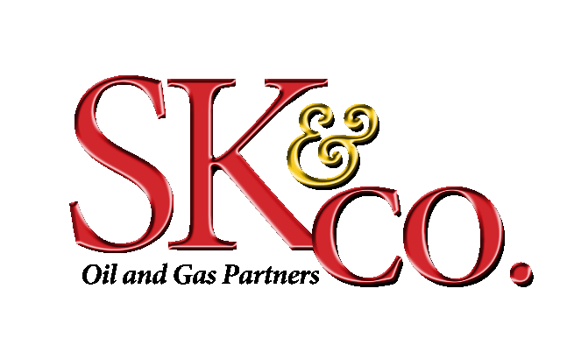

TABLE OF CONTENTS

SK & Company Page1

- Investment Strategy Page 3
- Management Team Page 5

Pan American Production Page 8

- Company History Page 9
- Management Team Page 10

Best Energy

- “Best Energy Updates Recent Funding, Acquisition and Page 12
Trading Activities” Rig Zone March 5, 2008
- “Best Energy concludes equity financing” Houston Business Page 14
Journal April 14, 2008

Oracle Energy Corp.

- ”J. Vela #1 spudded in Zapata County, Texas” Monday, Page 15
April 14, 2008

Ventum Energy

- Website Home Page Page 16

Ken-Tex Energy / Sam Spicer Page 17

- Company Information Page 18
- Sam Spicer Resume Page 19
- West Port Energy Partners – Energy Lending Review Page 21
- “Prospect Capital Provides Acquisition and Growth Financing Page 22
to Ken-Tex” Sec Info. 6/05/07
- “Prospect Capital Provides Acquisition and Growth Financing Page 24
to Ken-Tex” June 5, 2007

Sovereign Bank – Sam Spicer

- Sovereign Bank - Board of Directors Page 26
- Sovereign Bank – Energy Lending Page 27

Internet Sources and Links Page 28

Investment Strategy:

We structure Developmental Drilling Programs that take advantage of the high-risk exploratory efforts of others. Once oil and gas have been found the development of a field becomes a routine exercise with few, if any surprises. Technology has greatly reduced the risks of exploration and has had an even greater impact for those of us who follow up with developmental drilling. Many sites have 100% success after the initial discovery well proves up reserves.

Source of Prospects:

Deal Flow within the industry generally starts with relationships among geologists, engineers and operators. Our primary source of prospects come from operators who have already proven the viability of a site and wish to have us complete the find with our funds and management team. Most often, they stay in the projects and continue to co-ordinate operations.

An additional source of prospects may come from banks that are willing to loan on a project but require additional equity. We are able to bridge the equity gap with investor funds. This is a form of Mezzanine Financing that places us in a position to secure equity positions with the added benefit of lender recourse.

The Process of Selecting a Project:

The process of selecting a project is straight forward. The first step is to review a prospect with our geologists followed by an investigation of other activities that support our interest. Texas regulates the Oil and Gas Industry with great efficiency because it taxes hydrocarbons in lieu of a state income tax. Every barrel of oil is accounted for and a part of public information records. We know what every well is producing. Our decision to participate in a field will be based in part on these production records.

The rest of the process involves perfecting lease interests, title reviews, pipeline and crude sales contracts along with engineering and drilling arrangements. Our funds are released as needed against invoices in support of an audit trail.

Sources and Minimization of Risk:

The greatest risk in our projects lie in the talents and capabilities of the management team, its processes, and its commitment to serving our mutual interests. We believe we have a good team with great reputations and skill sets. The rewards for success are noteworthy and subordinated to the success of our investors. Following this, the risks associated with drilling and good completion are more likely to be associated with higher costs rather than outright failure. Finally, these are not exploratory endeavors so the risks associated with finding oil or gas are exceptionally low. Again, 100% success in developmental drilling is no longer uncommon.

Management of the Portfolio:

Oil and Gas production involves a team of people who are active managers. Daily visitation of a site is normal and supports constant supervision of data relating to production. Changes are monitored and indicate the need for adjustment of equipment and services. The team is diverse and includes general labor (pump monitors, equipment maintenance and repair, meter readers, haulers of crude, etc.), geologists and engineers, accounting and auditing personnel, operators who oversee the project and our own internal staff who serve in customer relations, finance, legal and operations capacities.

Other Factors to Consider:

Our portfolios are designed to serve the needs of those who desire a high and consistent cash flow, likely tax-free, while holding on to significant capital gains expectations.

We believe the possibility of a five-fold increase in five years is a supportable goal.

Management Team

Ownership currently consists solely of Dr. S. K. Sung as Founder and Chairman with Elaine Aldridge Head, PhD as equal co-owner, Founder and Secretary.

Dr. S. K. Sung - Founder and Chairman.

Industrialist, international businessman. Born in Hong Kong in 1910. Founded and operated thirteen corporations with offices in Switzerland, England, Canada, Australia, Thailand and the United States. Dr. Sung built the first high-rise condominium in Hong Kong and employed 2,200 people in operations ranging from textiles to manufacturing, (40% owner of the Raleigh Bicycle Company, England), to importer of fine watches and cameras.

In recent years Dr. Sung has become a private equity partner with energy companies and has helped finance the development of oil and gas fields in Texas and neighboring states. Dr. Sung has set up a private foundation to carry on his passion for the gospel of Jesus Christ and supports charitable works around the world.

Elaine Aldridge Head – Founder and Secretary

Born in 1945, a native Texan, Mrs. Head has served in both the public and private sector with early career experiences as executive assistant to founders of independent oil and gas operations. She managed coal, oil and gas production records and prepared production reports for the Texas Railroad Commission, the regulatory authority over the Texas oil and gas industry. She and her staff researched county land records, log libraries, gathered data and prepared reports for consideration in exploration and production projects.

Mrs. Head opened and managed the Public Affairs office for Houston Lighting and Power in Austin, Texas, reporting to the Group Vice-President of State Relations, researching and reporting industry issues relating to the Texas legislative agenda, and the Public Utility Commission. She monitored City Council meetings regarding a nuclear power plant and related lawsuit reporting findings and updates to the company CEO. This office monitored public and private sector data, researched relative issues and prepared reports as well as hosted members of the Legislature, State agencies, lobbyists, consultants and the media.

Mrs. Head was recruited into public service at the Texas Legislature initially as Chief of Staff for State Representative Gerald Geistweidt, and later for newly elected Senator Bill Ratliff who became Lt. Governor of the State of Texas. Senator Ratliff sat on the Appropriations and Finance committees as well as Ways and Means. She represented the elected member before state agencies, county and city elected officials, and constituents not only in drafting legislation but also in following it closely through hearings and each step of the process. She prepared district newsletters and oversaw mailings to constituents in district counties.

The Oil and Gas Industry has been firmly woven into her career in both public and private venues.

Dennis L. Head - President

Born in 1954. Trained in economics and finance at both the University of Michigan and the University of Texas, Mr. Head has enjoyed a successful thirty-year career in asset management and international finance. His career commenced in 1976 with a four-year appointment in Frankfurt, West Germany with a large U.S. insurance syndicate. He also founded and completed a three-year term as a Trustee for the American Society of Charitable Endowments, a non-profit public support organization that raised $20 Million in its first year of operations.

Mr. Head and his associated have participated in the management of portfolios exceeding U.S. $1 Billion and participated in equity and/or lending projects throughout the world. They funded a U.S. $100 Million resort development in Mexico; a joint venture with that country’s former Director of Investments, (Direct De Invessions De Fonatur) Mr. Gabriel Robles-Velarde. In addition, Mr. Head helped take Excel Realty Trust public on the New York Stock Exchange, which later merged with New Plan Realty.

Mr. Head is now engaged in International Investment and Merchant Banking projects in addition to serving as President and CEO of the company. He also continues to serve the public as a Director or Member of Trustee Boards for several charitable organizations

Robert H. Brown – Vice President

Born in 1951. Graduate of the University of Texas at Austin. Mr. Brown grew up in a family with ownership in over a dozen ranches near the great East Texas oil fields. This became the perfect training ground for oil and gas lease negotiations. When Mobil and Exxon set their sights on a large lignite lease in Cherokee County that included many of their ranches, Robert Brown and his father took on a very visible role of representing not only their acreage, but many of their neighbors’ leases as well. The final result was that the first year’s bonus went from $75.00 per acre to $275.00 per acre.

In contrast to representing the landowner's interest, Mr. Brown has also participated on the operator’s side of the table with direct investments in drilling programs and lease acquisition. He brings real insight to the table in the negotiation process, understanding concerns and expectations of both the royalty owner and the operator.

Mr. Brown has continued to develop and maintain many contacts within the oil and gas industry and brings a rich base of experience and contacts to the company.

W. Jamie Cotterell - Landman

Mr. Cotterell has 18 years experience as a Petroleum Landman. Jamie's function is to act as a Landman in land operations, including lease negotiations and acquisitions, due diligence, title, title curative, landowner relations, scouting of competitor activities, and all other associated landman activities.

Client companies have included Exxon Company USA, Texaco Exploration and Production Company, Pioneer Natural Resources, Inc., GLG Energy and Walter Oil & Gas.

Larry Cottingham – Legal Counsel

Mr. Cottingham is a graduate of Southern Methodist University with a B.A. and a Doctorate of Law. He served as a legal officer in the United States Air Force and returned as a Professor of Law and Assistant Dean of the Southern Methodist University Law School.

He later left the teaching of Law and went to work for an insurance company as Associate General Counsel for Insurance. Afterward, he attended the Wharton School at the University of Pennsylvania from which he holds a Bachelor's of Business Administration. He then returned to Dallas and engaged in investment banking and later received a Masters of Law in Taxation and has been involved in private practice since that time.

William M. Frew - Geologist
Mr. Frew has a Bachelors of Science (Geology) and a Masters of Science (Petroleum Geology) from the University of Michigan. His extensive work experience has been with CONOCO in Casper, WY; Roswell, NM; Corpus Christi, TX; Jackson, MS; Shreveport, LA and Houston, TX. Also with the Cockrell Corp., Houston, TX April 1971 - November 1973.

He remains in contact and part of Hamilton Bros. Oil Co., Chief Geologist, Transco Exploration Co., Gulf Coast Mgr., Southland Royalty Co., General Mgr., Pamale Petroleum Co., and a Consulting Geologist, all in Houston, TX. He is also the Sr. Vice-President for the Cenergy Exploration Co., Houston and Dallas, TX. He has been an Oil and Gas Consultant in Dallas, TX and chief exploration manager with Maguire Oil Company during eight year, non-exclusive retainer.
He has had professional associations with American Association of Petroleum Geologists
Society of Independent Professional Earth Scientists, No. 1932 Formerly- American Association of Petroleum Landmen (Assoc.), and Geological Societies of Corpus Christi, Dallas, Houston and Mississippi.

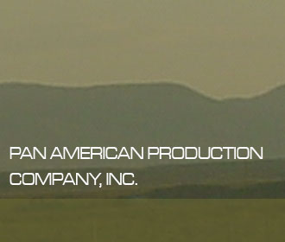

Pan American Production Company was formed in 2003. Larry Hargrave, CEO of Pan American, graduated from Lamar University in 1973, with a degree in Geology. His industry experience spans 34 years, and includes time spent in several different aspects of the business. Mr. Hargrave was chief geologist for Damson Oil in the Rocky Mountains, and supervised the geology and drilling / development of several thousand wells in Montana on the Blackfoot Indian reservation. This experience led to Mr. Hargrave developing extensive drilling, and downhole experience that would accompany his exploration background.

pan american production company, inc.
1010 lamar street, suite 1200
houston, texas 77002
713.933.2600(O)
713.933.2602(F)

In addition to geological and drilling expertise, Mr.Hargrave has designed and installed gas gathering systems in South Texas, collecting low volume gas from a network of over 400 miles. He has also designed and installed vapor recovery systems in gas condensate reservoirs in western Siberia,

During the downturn in the industry of the late 1980’s and early 1990’s, Mr. Hargrave acquired producing properties out of bankruptcy, redrilled, reengineered wellbores and surface facilities, improving net cash flows, and reselling these properties at a substantial profit.

Currently, Mr. Hargrave is utilizing his experience in downhole drilling to reenter wellbores in south Texas. He has developed the ability to identify bypassed potential production, reenter wells that have been plugged, and reestablish production at a fraction of the cost. Many of these wells still have production casing set, existing infrastructure, gathering systems, and severance tax abatements in place.

Pan American has acquired leases in over 30,000 acres in five counties, ranging from south Texas to central and southeast Texas. The business plan is to focus on areas where the Company can initiate low risk development drilling programs, and have the added potential to develop very high production opportunities in the immediate area. The optimum situation being the ability to generate cash flow from low risk drilling, controlling the destiny of the larger, more lucrative potential through steady growth and expansion.

The Company’s initial success came in Zapata County, through the reentry of the Gulf Oil Graciela Gonzales #1 well. Originally completed in the 2nd Hinnant sand, and having produced 1.5 BCFG through a natural completion, Pan Am reentered the well, completing in the bypassed 1st Hinnant sand for an initial rate of 1.3mmcfg. The Company controls several additional reentry wellbores in Zapata County, and has identified more than a dozen additional candidates.

The Company identified and acquired an interest in an old field inside the city limits of Houston, Texas. The Dyersdale Field, Harris County, Texas, was producing approximately 50 bopd and 350 mcfgd. Mr. Hargrave implemented some field efficiencies to improve profitability, and with the assistance of Mr. Gardner and 3D seismic, available across the field, drilled an infield development well, that had initial production rates of almost 300 bopd, and has been flowing naturally in the range of 70 bopd for over six months

PAN AMERICAN PRODUCTION COMPANY, INC

MANAGEMENT

Larry Hargrave, CEO and Director - Mr. Hargrave is a multi-degreed petroleum geologist with over 30 years industry experience as an operator, explorer, and exploitation specialist. From 1973 to 1988, Mr. Hargrave worked for independent oil and gas operators including Damson Oil & Gas, Alliance Exploration, and Global Marine. He also worked for Johnson-Schlumberger, during which time he acquired extensive training utilizing a variety of down hole completion and production techniques and tools. He has been an independent geologist and consultant in the oil and gas industry since the 1980’s. He is personally responsible for the discovery and development of 14 significant domestic and international oil and gas fields. In 1988, he founded and served as president of both NGL Industries, which installed and operated low-pressure natural gas gathering systems in South Texas, and Commonwealth Energy, which developed and sold geologic prospects and producing properties. Mr. Hargrave sold both companies in 1996. In 1992, Mr. Hargrave became a founding partner and president of Arctic Gas Processors Ltd., which was headquartered on the island of Jersey of the Channel Isles. Arctic Gas Processors Ltd., in conjunction with the World Bank, pursued and developed various natural gas processing opportunities in the former Soviet Union, Africa, and Trinidad. Mr. Hargrave has been the President and owner of American Rig Housing from 1996 until its planned acquisition by Rig Acquisition Drilling Company.

Denver Gardner, President – Mr. Gardner received his BS in geology from the University of Southern California in 1978. On graduation Mr. Gardner went to work for Ferguson and Bosworth in Bakersfield, California, a very successful private independent oil and gas exploration company. Mr. Glenn Ferguson, also a graduate of USC, class of '28, had production in California, Texas, Nevada, Louisiana, and Wyoming. Mr. Gardner trained in the areas of deep, high risk, high potential Lower Cretaceous trends, such as the Woodbine, Edwards shelf edge, Sligo shelf edge, and West Texas Devonian. Prospects were generated utilizing regional seismic, generating 100+BCFG prospects for sale to the industry, primarily major independent oil companies, such as Amerada Hess, Pennzoil, Transco, Texoma, King Ranch Oil & Gas, among others.

Mr. Gardner became an independent in 1988, continuing the generation of large, high risk prospects and coupling this effort with production acquisitions, and investor participation in third party generated prospects. The highlight was the participation in a 100 BCFG discovery in an untested fault block in Chocolate Bayou Field, Brazoria County, Texas. This discovery was on a farmout from Philips Petroleum, in a field that has produced 2 TCFG.

The industry downturn of the late 1980's and 1990's required a shift in prospect emphasis as the major independent oil companies deemphasized onshore US, making deep, high risk projects too difficult to sell. Mr. Gardner switched focus to the shallow, amplitude projects ("bright spots"), and stratigraphic plays in the Yegua, James Lime, Miocene and Frio formations. This effort resulted in four discoveries in Wharton, Lavaca, and Maverick Counties.

In 2003, Mr. Gardner joined Mr. Larry Hargrave, to form Pan American Production Company. This combination of two diverse geological backgrounds created a mix of pure exploration, with an emphasis on geophysical (seismic) tools, coupled with strong developmental (geological engineering), utilizing production enhancing techniques.

Together, Mr. Hargrave and Mr. Gardner combine their experience to identify areas where initial risk is low, yet have the opportunity to apply exploratory techniques, to create significant high potential to a project.

The Company is currently developing several reentry projects in the overpressured Wilcox of South Texas, with over 1000 acres under lease. They have over 15,000 acres in the Canyon, Ellenburger, and Strawn trend of South Central Texas with the potential for over 100 BCFG. Prospect potential of over 500 BCFG in the Lower Cretaceous trends across Texas have also been developed, along with Miocene, Frio, Wilcox, and Yegua projects with over 100 BCFG potential.

Best Energy Updates Recent Funding, Acquisition
and Trading Activities
Best Energy Services 3/5/2008
URL: http://www.rigzone.com/news/article.asp?a_id=57843
Best Energy Services, Inc., formerly Hybrook Resources, Inc., issued a corporate update detailing a series of recent events and transactions that have established Best Energy Services as an operating company in the oil field service sector.
Specifically, on February 14, 2008, the company secured a $25 million term and revolving credit facility from PNC Bank. On the same date, Best Energy Services closed on a private equity offering that as of that date yielded $8.64 million in gross proceeds to the company. The offering provided for the unregistered sale of 8,640 Units, comprising the total issuance of 5.4 million shares of common stock and 777,600 shares of Series A Convertible Preferred Stock to 64 institutional and accredited investors.
Each unit, priced at $1,000, consisted of 625 shares of common stock and 90 shares of Series A Convertible Preferred Stock. The Series A Convertible Preferred Stock has a stated face value of $10 per share, which shall be redeemed by the company using no less than 25% of its net after tax income each year. The unredeemed portion of the face value will bear interest at an annual rate of 7%, payable quarterly in cash or in kind at the then-current market price, at the company's option. The unredeemed face value may be converted into common stock by the holder at a conversion price of $4.00 per share, or by the company at a conversion price of $4.00 in the event that the company's common stock closes at a market price of $9.60 per share or higher for more than 20 consecutive trading days.
The New York City-based investment banking firm of Andrew Garrett, Inc. served as the exclusive placement agent on the transaction.
In tandem with the closing of both the debt and equity financings, Best Energy Services completed the following planned acquisitions and asset purchases: acquired 100% interest in Best Well Service, Inc.; acquired 100% interest in Bob Beeman Drilling Company; acquired certain assets of American Rig Housing, Inc. Specifically, Best Energy Services acquired from its owner, Larry Hargrave, all customers, oil field rig houses, motor vehicles, rolling stock and related equipment and right and title to the name "American Rig Housing." The company also acquired certain assets of BB Drilling, Co. from its owner, Bob Beeman, consisting of drilling rigs, motor vehicles, rolling stock, pumps and related tools and equipment and certain assets of Drill Site Services & Investments, LLC from its owner, Todd Beeman, consisting of drilling rigs, motor vehicles, rolling stock, pumps and related tools and equipment.
Retaining much of their pre-existing corporate structure and management teams, Best Well Service and Bob Beeman Drilling Company will operate as wholly owned subsidiaries of Best Energy Services, but will collaborate to leverage and optimize their respective strengths and complementary service offerings.
Best Energy Services also announced the formation of its new Board of Directors providing for the appointment of the following members: Larry Hargrave, Chairman and Chief Executive Officer of the Company; Tony Bruce, Director; Mark Harrington, Director; Jim Carroll, Director; David Gad, Director; and Joel Gold, Director.
On February 14, 2008, the Board voted in favor of changing the company's corporate name from "Hybrook Resources, Inc." to "Best Energy Services, Inc.;" its ticker symbol from "HYBK" to "BEYS," and its fiscal year end from January 31 to December 31, in keeping with the current fiscal year observed by both of its acquired subsidiaries. As a result of the fiscal year change, the company will report its 2007 year end results on or before March 31, 2008 and its consolidated first quarter results on or before May 15, 2008.
After factoring shares issued in association with the private equity offering and noted acquisitions, the company has 17,551,875 shares of common stock and 777,600 Series A Preferred Stock issued and outstanding.
The company filed two Form 8-K reports, dated February 21, 2008 and March 4, 2008, with the U.S. Securities and Exchange Commission, which provide more detailed information relative to the financing transactions, acquisitions and other business matters described in this news release.
Commenting on Best Energy Services' many recent achievements, CEO Larry Hargrave noted, "There is much to be proud of and plenty of hardworking people to credit for our success to date. But, there is also much hard work ahead of us if we are to realize our growth objectives. The consolidation of Best Well Service, Bob Beeman Drilling and American Rig Housing under the Best Energy umbrella has empowered us with a fundamentally strong and profitable operating platform that is expected to support and fuel solid organic growth over the coming years."
Continuing, Hargrave said, "Given the proceeds from our recent equity offering and the additional funds available to us through our $25 million revolving credit facility, we enjoy the tactical advantage of being able to move quickly and decisively on those business opportunities that are well aligned with our long term growth strategy. Moreover, by relying upon and leveraging the skill and experience of our management team and Board of Directors, 2008 promises to be a very productive year for our company, marked by important milestones and accomplishments."
In closing, Hargrave added, "I'd like to formally welcome our new shareholders and thank everyone for your collective show of confidence in Best Energy Services. We look forward to keeping you well informed of our progress and intend to work very hard to build a lasting, successful company with whom we will all be proud to be associated."
The company is currently developing a corporate website that is expected to be launched in the near future.


Article found at: http://www.rigzone.com/news/article.asp?a_id=57843

Monday, April 14, 2008

Best Energy concludes equity financing

Houston Business Journal - by Greg Barr Reporter
Best Energy Services Inc. raised an additional $5 million through its current equity offering to reach $13.5 million in proceeds, the company said Monday.
Total proceeds for Houston-based Best Energy (OTCBB: BEYS) included $1.8 million originally invested as bridge financing for the acquisition of some assets of American Rig Housing Inc. the holders of which elected to convert to equity under the terms of this offering.
A total of 8.4 million common shares and 1.2 million preferred shares were issued through the offering. Units were sold at $1,000 apiece, consisting of 625 common shares and 90 preferred shares.
The exploration and production company used the first chunk of equity raised -- about $8.6 million -- to assist in the purchase of Kansas-based rig operator Best Well Service Inc. and Utah-based Bob Beeman Drilling Co. in February.

All contents of this site © American City Business Journals Inc. All rights reserved.

Article found at: http://houston.bizjournals.com/houston/stories/2008/04/14/daily3.html
For more information, send questions and comments to

ORACLE ENERGY CORP. :
http://www.oracleenergy.com/ : News Releases

Mon Apr 14, 2008
J. Vela #1 spudded in Zapata County, Texas

April 14, 2008, Oracle Energy Corp. ("Oracle Energy") (OCL-TSX.V)(O2E-Frankfurt) announces it has been notified by Ventum Energy LP ("Ventum") that drilling operations on the J. Vela #1 well in Zapata County, Texas have commenced today.Ventum is the operating partner for the well.
.
The new well is to be located approximately 150 feet from the existing Jonnell-Zamora # 1 well and will be drilled to a depth of 8400 feet to test the 1st and 2nd Hinnant formations.
The Jonnell Gas Company Zamora #1 was drilled in April of 1961 and was completed as a gas well from the 1st Hinnant sand. The top 10 feet of the 1st Hinnant sand was perforated and flowed at rates up to 4 mmcfg/d. The well was never commercially produced due to being a dry gas discovery. In 1961, no market existed to transport dry gas.
Oracle Energy has an 18.75% interest on the 640 acres oil and gas lease in Zapata County, Texas.
Oracle Energy has a diversified portfolio of oil and gas interests in Romania, the USA and Italy.
ON BEHALF OF THE BOARD
"Nasim Tyab"
Nasim Tyab
President

Article found at: http://www.oracleenergy.com/s/NewsReleases.asp?ReportID=296123&_Type=News-Releases&_Title=J.-Vela-1-spudded-in-Zapata-County-Texas

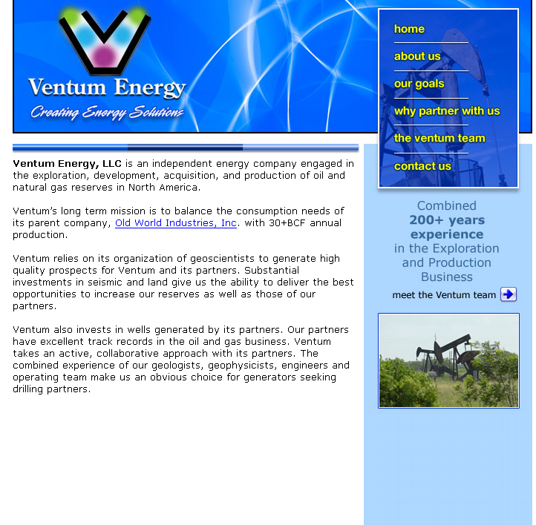

Website home page: http://ventumenergy.com/

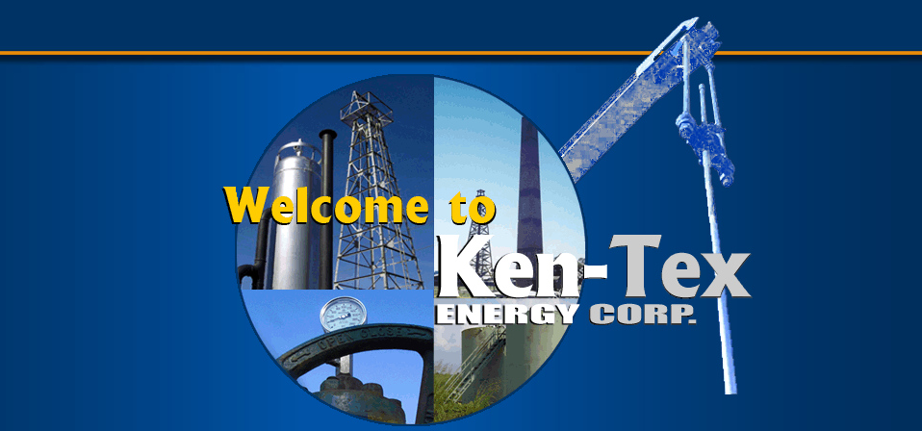

Ken-Tex Energy Corp./ KT Operating Company LLC
7557 Rambler Road Suite 915 Dallas, TX 75231
Telephone: (214)891-7550 Fax: (214) 891-7551

Ken-Tex Energy Corp. is a Dallas, TX based independent oil and gas exploration and production company focused on proven, well developed oil and gas basins in the United States that support repeatable drilling opportunities.
The Company is engaged in the operation and development of its principal reserves located within over 20,000 drillable acres in the Texas counties of Angelina, Jasper and San Augustine.
We are currently focusing on an aggressive re-entry lateral drilling program within the Austin Chalk formation of the Brookeland Field. The re-entries will be supplemented with infield drilling for proved undeveloped reserves. The program spudded in late August 2007 and is expected to continue into 2008 and beyond.
Sam Spicer
President
(214) 891-7552
sam@kentexenergy.com
Mike Pearson
Vice President/CFO
(214) 891-7553
mike@kentexenergy.com
Fred McDonald IV
Vice President/General Counsel
(214) 891-7554
fred@kentexenergy.com

Website address is: www.kentexenergy.com

Samuel G Spicer

Sam is a senior executive with 22+years Oil & Gas Industry and 9+years Banking Industry. Approved $ 100MM+ in loan commitments since the opening of Sovereign Bank. Experience in Acquisitions, Production and Divestitures.
Key Accomplishments

- Pleasant Ridge Drilling Project is 2500 plus acreages, in the middle of the Pleasant Ridge Oil Field in Leon County, Texas which was discovered in 1964. The estimated oil in place within the project area is over 30 million barrels of oil in just the Woodbine alone in Pleasant Ridge. Of 32 wells drilled to date, 31 were successfully completed. There are an additional 20 plus puds to drill within this field.

- Hilltop: Generated the prospect and participated in the drilling of the second deepest well in East Texas history (TVD 22,000’), which led to the discovery of one of the largest natural gas discoveries in Texas in recent history. 9 wells have been completed with 2 rigs currently active in the field.

- Brookeland: Completed acquisition in June 2007. The acquisition was funded by a $17 million senior note facility provided by Prospect Capital Corporation and Petro Capital Securities, LLC. Drilling of re-entry K-laterals has begun.

- Haas Petroleum Engineering Services, Inc has prepared a reserve report indicating net proved reserves of $161 million dollars.

- Tigre Project: Generated the prospect and acquired two 3-D seismic shoots that led to the discovery of an underdeveloped salt dome. Project potential gross revenues exceed $ 4 Billion.

Professional Experience

Mercantile Bank Founding Shareholder
- Bank was subsequently sold to Colonial Bank.

Sovereign Bank, Dallas, TX Founding Shareholder 2004- Present
- Bank duties include: Audit Committee, Director’s Loan Committee, Advisory Board and Directing the Energy Department, since 2004.
- Has $500 Million under assets and Generated over $100 Million in Loans in the oil and gas division

Kentex Energy, L.L.C., Dallas, Texas President 1998 – Present
- Co-Founded the Company
- This company specializes in generating prospects and developing properties in South Louisiana, East Texas and South Texas. Kentex owns 2-D and 3-D seismic data in Louisiana and Texas and has a strategic partnership with INEXS, Inc. for geophysical services.

Hilltop Field
- Generated the prospect and participated in the discovery well that led to the development of the deep Bossier Sands Play in Leon County. Hilltop field has developed into one the largest natural gas discoveries in recent Texas history.
- The first well was drilled to a TVD of 22,000’ which is reported to be the second deepest well in the history of East Texas
- Completed a roll-up of assets in exchange in receipt of stock with Gastar Exploration Ltd, (“GST” on the AMEX), which is believed to have increased GST’s market cap by over $300 million.

Brookeland Austin Chalk Field
- Completed buy-out of partners on 20,000 plus acres (Brookland Field).

Spicer Oil Company, Inc., Dallas, Texas President 1985 – Present

- Independent Producer and Operator of Oil & Gas Properties.
- Spicer Oil purchases, drills and produces Oil & Gas properties in Texas and Louisiana including Inland Waters.
- Initiates and generates Drilling Prospects and Producing Property acquisitions
- Owned and operated Natural Gas Gathering and Pipeline Systems
- Proficient in management, operating, accounting and reporting responsibilities
- The company has participated in over a 100 wells in Texas and Louisiana

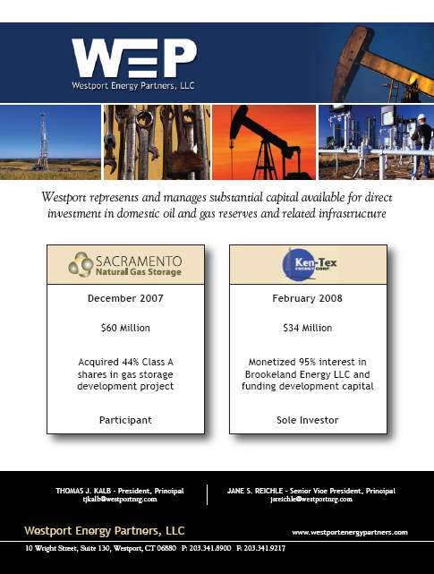

Prospect Energy Corp · 8-K · For 6/5/07 · EX-99

Filed On 6/5/07 11:27am ET · SEC File 814-00659 · Accession Number 1102624-7-147
Top of Form

6/05/07 Prospect Energy Corp 8-K{8,9} 6/05/07 2:2 Internet Wire Inc/FA

Current Report · Form 8-K
Filing Table of Contents
Document/Exhibit Description Pages Size

1: 8-K Prospect Capital 8-K HTML 7K
2: EX-99 Prospect Capital Press Release HTMl 7k

EX-99 · Prospect Capital Press Release

This is an EDGAR HTML document rendered as filed. [ Alternative Formats ]

Prospect Capital Provides Acquisition and Growth Financing to Ken-Tex
NEW YORK, NY -- 06/05/2007 -- Prospect Capital Corporation (NASDAQ: PSEC) ("Prospect") announced today that it has provided growth financing of approximately $10.8 million to Ken-Tex Energy Corp. ("Ken-Tex"), located in Dallas, Texas.
Founded in 1995, Ken-Tex is an independent energy company engaged in the development and production of crude oil and natural gas hydrocarbons in East Texas. Ken-Tex owns 18,000 net acres in the Brookeland Field in San Augustine, Jasper, and Angelina Counties in the vicinity of the Sam Rayburn Reservoir. The Brookeland Field is part of the Austin Chalk play, a prolific, fractured oil reservoir stretching from Texas to Louisiana. Ken-Tex focuses on the drilling of K-lateral wells in new and existing wellbores to maximize recovery of leased reserves. Ken-Tex is led by Samuel Spicer, who has more than two decades of experience in the oil and gas industry, and who serves on the board of directors of Sovereign Bank in Dallas.
Ken-Tex is utilizing Prospect's financing for the acquisition of a larger working interest in its leasehold, the drilling of additional K-laterals, and the acquisition of adjacent leases. Prospect's co-investor is an affiliate of Petro Capital Group, an experienced investment firm in Dallas. Prospect's investment is in the form of a senior secured debt instrument with a first lien on all assets of Ken-Tex, including receivables, wells, leases, pipelines, and other surface infrastructure. Prospect has received a significant overriding royalty interest and net profit interest as part of its investment.
"Prospect Capital is an ideal partner for our growth and development needs," said Samuel Spicer, CEO of Ken-Tex.
"Given the management team's track record, we are pleased to be supporting its capital requirements," said David Belzer, a managing director with Prospect Capital Management.
ABOUT PROSPECT CAPITAL CORPORATION
Prospect Capital Corporation (www.prospectstreet.com) is a closed-end investment company that lends to and invests in private and microcap public businesses. Prospect Capital's investment objective is to generate both current income and capital appreciation through debt and equity investments.
Prospect Capital has elected to be treated as a business development company under the Investment Company Act of 1940 ("1940 Act"). We are required to comply with a series of regulatory requirements under the 1940 Act as well as applicable NASDAQ, federal and state laws and regulations. We have elected to be treated as a regulated investment company under the Internal Revenue Code of 1986. Failure to comply with any of the laws and regulations that apply to Prospect Capital could have a material adverse effect on Prospect Capital and its shareholders.
This press release contains forward-looking statements within the meaning of the Private Securities Litigation Reform Act of 1995. Any such statements, other than statements of historical fact, are likely to be affected by other unknowable future events and conditions, including elements of the future that are or are not under the Company's control, and that the Company may or may not have considered; accordingly, such statements cannot be guarantees or assurances of any aspect of future performance. Actual developments and results are highly likely to vary materially from these estimates and projections of the future. Such statements speak only as of the time when made, and the Company undertakes no obligation to update any such statement now or in the future.
Please send investment proposals to:

Grier Eliasek
President and Chief Operating Officer
grier@prospectstreet.com
(212) 448-9577

Filing Submission - Alternative Formats (Word / Rich Text, HTML, Plain Text, SGML, XML, et al.)

Copyright © 2008 Fran Finnegan & Company All Rights Reserved.
www.secinfo.com - Wed, 7 May 2008 15:29:52.2 GMT - Help at SEC Info

Article found at: http://www.secinfo.com/d11kpf.u4s.d.htm

SOURCE: Prospect Capital Corporation
Jun 05, 2007 09:15 ET

Prospect Capital Provides Acquisition and Growth Financing to Ken-Tex
NEW YORK, NY--(Marketwire - June 5, 2007) - Prospect Capital Corporation (NASDAQ: PSEC) ("Prospect") announced today that it has provided growth financing of approximately $10.8 million to Ken-Tex Energy Corp. ("Ken-Tex"), located in Dallas, Texas.
Founded in 1995, Ken-Tex is an independent energy company engaged in the development and production of crude oil and natural gas hydrocarbons in East Texas. Ken-Tex owns 18,000 net acres in the Brookeland Field in San Augustine, Jasper, and Angelina Counties in the vicinity of the Sam Rayburn Reservoir. The Brookeland Field is part of the Austin Chalk play, a prolific, fractured oil reservoir stretching from Texas to Louisiana. Ken-Tex focuses on the drilling of K-lateral wells in new and existing wellbores to maximize recovery of leased reserves. Ken-Tex is led by Samuel Spicer, who has more than two decades of experience in the oil and gas industry, and who serves on the board of directors of Sovereign Bank in Dallas.
Ken-Tex is utilizing Prospect's financing for the acquisition of a larger working interest in its leasehold, the drilling of additional K-laterals, and the acquisition of adjacent leases. Prospect's co-investor is an affiliate of Petro Capital Group, an experienced investment firm in Dallas. Prospect's investment is in the form of a senior secured debt instrument with a first lien on all assets of Ken-Tex, including receivables, wells, leases, pipelines, and other surface infrastructure. Prospect has received a significant overriding royalty interest and net profit interest as part of its investment.
"Prospect Capital is an ideal partner for our growth and development needs," said Samuel Spicer, CEO of Ken-Tex.
"Given the management team's track record, we are pleased to be supporting its capital requirements," said David Belzer, a managing director with Prospect Capital Management.
ABOUT PROSPECT CAPITAL CORPORATION
Prospect Capital Corporation (www.prospectstreet.com) is a closed-end investment company that lends to and invests in private and microcap public businesses. Prospect Capital's investment objective is to generate both current income and capital appreciation through debt and equity investments.
Prospect Capital has elected to be treated as a business development company under the Investment Company Act of 1940 ("1940 Act"). We are required to comply with a series of regulatory requirements under the 1940 Act as well as applicable NASDAQ, federal and state laws and regulations. We have elected to be treated as a regulated investment company under the Internal Revenue Code of 1986. Failure to comply with any of the laws and regulations that apply to Prospect Capital could have a material adverse effect on Prospect Capital and its shareholders.
This press release contains forward-looking statements within the meaning of the Private Securities Litigation Reform Act of 1995. Any such statements, other than statements of historical fact, are likely to be affected by other unknowable future events and conditions, including elements of the future that are or are not under the Company's control, and that the Company may or may not have considered; accordingly, such statements cannot be guarantees or assurances of any aspect of future performance. Actual developments and results are highly likely to vary materially from these estimates and projections of the future. Such statements speak only as of the time when made, and the Company undertakes no obligation to update any such statement now or in the future.
Please send investment proposals to:
Grier Eliasek
President and Chief Operating Officer
grier@prospectstreet.com
(212) 448-9577

Article found at: http://www.marketwire.com/mw/release.do?id=738999&k


Board of Directors
 |  | 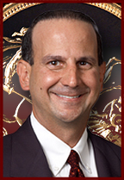
Roy J. Salley  Chief Executive Officer/ Chairman  Sovereign Bank |  | Thomas J. Mastor  President  Sovereign Bank

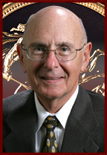 |  | 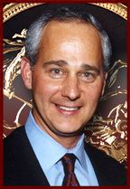 |  | 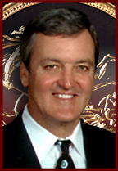
Robert Blumin  President  RBI Real Estate |  | Michael W. Dardick  President  Granite Properties |  | Richard S. Hill  Partner  Hill Partners
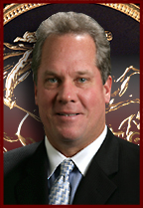 |  | 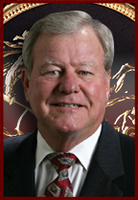
Samuel Spicer  Chief Executive Officer  Kentex Energy, LLC |  | Donnie Williams  Area President - Austin  Sovereign Bank
Energy Lending
The energy business is very specialized. As a result, it is important to find a bank that understands your company and the risks and opportunities in the oil and gas industry.
Sovereign Bank understands these risks and opportunities and is committed to the oil and gas industry. Its Energy Lending Department is focused on providing long-term assistance and support to the privately held and independent segment of the oil and gas market. Whether handling the loan directly or arranging participation in larger, multi-bank syndications, Sovereign has the expertise to review and identify the financing to meet the needs of the specific industry sector, such as:
- Exploration and production companies
- Exploration and production acquisitions
- Capital for drilling and development programs
- Natural gas gatherers, processors & marketers
- Equipment purchases/leases
Working capital
A company may need to move quickly when opportunities arise and Sovereign Bank is prepared to move quickly with you. Additional advantages of dealing with an independent bank’s energy lending department include: lower costs, lower commitment fees and legal expenses, and lending requests processed in a timely and cost-effective manner.
Designed to meet the needs of the industry, Sovereign Bank’s corporate services include:
- Term credit facilities
- Revolving lines of credit
- Letters of credit
- Private Banking

Web Pages are located at: http://banksov.com/boardofdirectors.htm
http://banksov.com/energylending.htm
Sovereign Bank Website: www.banksov.com

Internet Sources and Links

SK & Company

http://skoilandgas.com/

Pan American Production

http://panamericanproduction.com/fw/main/default.asp

Best Energy

“Best Energy Services, Inc. Issues Formal Update on Recent Funding, Acquisition and Trading Activities” MSN Money March 8, 2008

http://news.moneycentral.msn.com/ticker/article.aspx?Feed=PR&Date=20080305&ID=8285047&Symbol=BEYSFirefoxHTML\Shell\Open\Command

“Best Energy Updates Recent Funding, Acquisition and Trading Activities” Rig Zone March 5, 2008

http://www.rigzone.com/news/article.asp?a_id=57843

“Best Energy concludes equity financing” Houston Business Journal April 14, 2008

http://houston.bizjournals.com/houston/stories/2008/04/14/daily3.html

Oracle Energy Corp.
”J. Vela #1 spudded in Zapata County, Texas” Monday, April 14, 2008

http://www.oracleenergy.com/s/NewsReleases.asp?ReportID=296123&_Type=News-Releases&_Title=J.-Vela-1-spudded-in-Zapata-County-Texas

Ventum Energy

http://ventumenergy.com/

Sovereign Bank – Sam Spicer

http://banksov.com/boardofdirectors.htm

http://banksov.com/energylending.htm

Ken-Tex Energy – Sam Spicer

http://kentexenergy.com/

“Prospect Capital Provides Acquisition and Growth Financing to Ken-Tex” Sec Info. 6/05/07

http://www.secinfo.com/d11kpf.u4s.d.htm

“Prospect Capital Provides Acquisition and Growth Financing to Ken-Tex” June 5, 2007

http://www.marketwire.com/mw/release.do?id=738999&k

