EXECUTIVE BIO

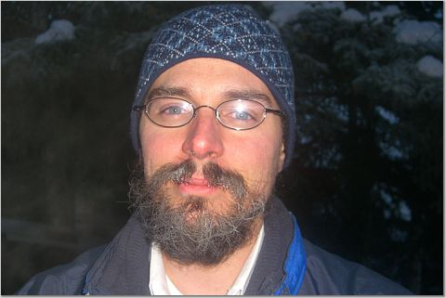

Robert W. Kinsey, MBA, PE
SK & Co. Oil & Gas
Operations Manager / Engineer

Mr. Kinsey joined SK & Co. Oil & Gas in 2009 as Operations Manager/Engineer, bringing with him thirteen years of accomplished experienced in Oil & Gas Operations Management that began in 1996 at Sierra Engineering where he held the position of Drilling Engineer/Superintendent.

Most recently, Mr. Kinsey was Vice President of Operations for KD Energy. He directed the logistical planning, design, approval and execution of well intervention projects involving workover, well stimulation, well recompletion and drilling operations on all operated properties. Mr. Kinsey also organized the recruitment, training, leadership and evaluation of field specialists and associates. He successfully grew the company from ~300 BOE to ~1000 BOE in less than one year while cutting OPEX by 45% from the previous operator.

Mr. Kinsey was Operations Manager/Engineer for Isramco, Inc., he was fully responsible for the day-to-day management of the Company's three wholly owned subsidiaries Isramco Energy LLC, Jay Petroleum LLC, and Jay Management Company, LLC) that support the Company's business operations. In this position, Mr. Kinsey provided executive leadership in all areas of the Company's acquisition, exploration, operation, development and transportation of crude oil and natural gas properties. Most notably, this includes the Company's March 2007 "Five States Acquisition" of oil and gas properties in Texas and New Mexico from Five States Energy Company, LLC for an aggregate purchase price of $92 million. The success of this strategic undertaking resulted in the addition of 600 wells to the Company's portfolio of properties in Texas, Mexico and Oklahoma.

Prior to joining Isramco, Mr. Kinsey held the position of Senior Drilling Engineer for Fairweather E&P Services, Inc. based in Anchorage, Alaska. This was a contract position under Pioneer Natural Resources (NYSE: PXD), one of the first independent companies to engage in exploration and well drilling operations on the North Slope, resulting in the discovery of the Oooguruk field. As part of Mr. Kinsey's role in heading the evaluation of field drilling initiatives for offshore developments that include both onshore-extended reach and offshore-platform scenarios, Mr. Kinsey led the success of the Company's Cosmopolitan Unit project. At the helm of this project, Mr. Kinsey fully managed all development-engineering operations along the Cook Inlet spanning 25,000 acres. Beyond his technical and project management role, Mr. Kinsey contributed to all areas of workforce management, contractor relations, safety and environmental compliance, contingency planning, and contract negotiations.

From 1996 to 2005, Mr. Kinsey held tenure as Drilling Engineer/Superintendent with Sierra Engineering. In this capacity, Mr. Kinsey fully managed both offshore and land based drilling rig operations, including deepwater and subsea projects for major clients such as Houston Exploration, Shell, Occidental and Exxon Mobil. The success of these key projects rested on Mr. Kinsey's technical expertise and ability to evaluate drilling programs, supervise up to 250 field personnel, control costs, and manage contractors.

Mr. Kinsey holds a Master of Business Administration from the University of Cincinnati, a Bachelor of Science degree in Petroleum Engineering from the University of Louisiana and a Bachelor of Science degree in Industrial Psychology from the University of Central Florida.

Mr. Kinsey is a Licensed Petroleum Engineer from the state of Alaska, and is a member of the National Society of Professional Engineers (NSPE) and the Society of Petroleum Engineers (SPE).

With a well-defined management style, business acumen, and expertise in onshore and offshore, shallow/deepwater and extended-reach drilling operations, Mr. Kinsey's broad knowledge and experience have contributed to success of major drilling projects and business growth initiatives throughout his career.

Mr. Kinsey currently resides happily in Houston, Texas with his wife Barbara and three young children.

