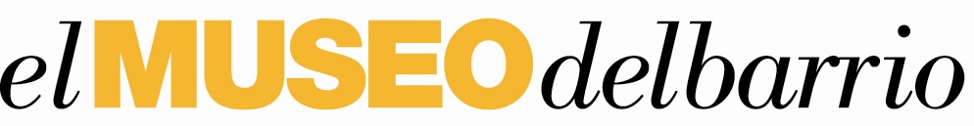
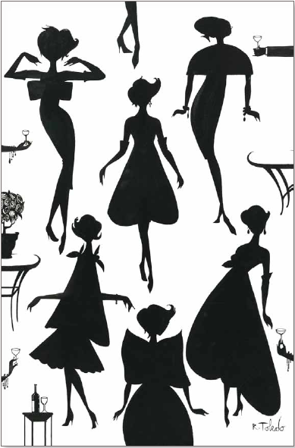

El Museo’s Gala ‘09
Wednesday, May 20th

The MOST ELEGANT evening in Latin New York’s Calendar

Gala Chairmen
Yaz + Valentín Hernández | Ruben + Isabel Toledo

Latin Portraits and Limited EditIoN Artist CigArs
Sales to Benefit EL Museo

El Museo's ‘09 Gala is planned for Wednesday May 20th at Cipriani 42nd Street, in New York City. The Gala chairs are again Yaz and Valentín Hernández with Isabel and Ruben Toledo. This year the gala honors the President of the Ford Foundation, Luis Ubiñas; Tony Award winning composer and lyricist Lin-Manuel Miranda; and the extraordinary musical producer/ performing artist team of Gloria and Emilio Estefan. The evening begins with cocktails at seven o’clock followed by dancing and dinner at eight o’clock.

In a first time collaboration, Ruben Toledo, together with children from El Museo’s Classroom Connections program, have created a whimsical gallery of 68 portraits, including some of the most famous faces in Latin American history and culture, as well as leading Latino New Yorkers. The pictures have been created to decorate El Museo Gala ’09. Each portrait, priced at $500 sold that evening will directly benefit both El Museo’s Classroom Connections program and Amber Charter School in East Harlem Charter School.

In a process that Ruben likens to a game of musical chairs, these portraits were first sketched by Ruben, and then the students each contributed a single feature before moving to the next portrait. These one-of-a-kind masterpieces will be offered for sale via silent auction to benefit El Museo.

“Ruben’s wonderful project truly reflects the heart of El Museo’s mission—connecting art with education and community,” says El Museo’s director, Julián Zugazagoitia. “We are thrilled to be able to join Ruben’s tremendous talent with the fresh eyes of children, to depict some of our most cherished Latino icons.”

The Latino icons represented in the collection include designers Maria Cornejo, Francisco Costa, Carolina Herrera, Narciso Rodriguez, Angel Sanchez, and Isabel Toledo, artists Salvador Dali, Frieda Kahlo, Jose Clemente Orozco, Diego Rivera, and celebrites Christina Aguilera, Penelope Cruz, Placido Domingo, Salma Haeykm John Leguizamo, Jennifer Lopez, Ricky Martin, and more.

Limited edition cigars, with an exquisite lacquered box and band designed by Ruben Toledo, have been created for El Museo in conjunction with La Flor Dominicana, the Dominican Republic's leading maker of fine cigars. Packaged in a luxurious white box with black silhouetted designs inside and out, each cigar features a gold-embossed band, all designed by Toledo. The cigar boxes will be sold for $600 with net proceeds going to El Museo. Each comes with a numbered certificate signed by Ruben Toledo. The edition is limited to 2,000.

The gala’s stellar honorary committee includes Jonathan Adler, Jose Solis Betancourt, Tory Burch, Iris Cantor, Edmundo Castillo, Maria Cornejo, Francisco Costa, Christian Cota, Simon Doonan, Patricia Field, Alex Gonzalez, Carolina and Reinaldo Herrera, Reed Krakoff, Isaac Mizrahi, Candy Pratts Price, Brian Reyes, Narciso Rodríguez, Ralph Rucci, Zang Toi, Richard Turley, Diane von Furstenberg, and Jason Wu.

The Gala Vice Chairs are Joseph and Carmen Ana Unanue, Ramiro J. Ortiz, and Sarah Wolfe. Coromoto Atencio, Mayra Hernandez, Michel Heredia, Lusiana Mendoza, Jana Pasquel de Shapiro, Leticia Presutti, Gabriel Rivera, Samantha Thompson, and Whitney Wolfe are Junior Chairs.

El Museo’s Gala has become one of the most glamorous evenings on the New York social calendar, with guests each year flying in from South America, the Caribbean, and Europe. This elegant evening begins with mariachis during the cocktail hour. The Bob Hardwick Orchestra, playing a specially-selected program of Latin music, provides dancing during and after dinner. This is traditionally one of the most joyous evenings in New York with guests lingering late into the night. It’s a grand occasion that raises significant funding for the museum’s education and community outreach programs. It has also come to symbolize the pride Latin Americans and Latinos in New York take in their museum.

Heralded by The New York Times as “an institution in its ascendancy”, El Museo del Barrio is recognized as the nation’s premier institution presenting and preserving Latino, Caribbean, and Latin America art and culture. As the only museum in New York City that specializes in representing these cultures, El Museo del Barrio continues to have a significant impact on the cultural life of New York City and is a major stop on Manhattan’s Museum Mile on Fifth Avenue. El Museo thrives on the sustained excellence of its permanent collection, varied exhibitions, publications, and education and public programs. Currently El Museo is undergoing a $28 million-dollar facelift, which will be unveiled this fall in a series of reopening celebrations.

For press information, please contact:  Jonathan Marder + Company  Ren Herring  ren.herring@gsmltd.net / 212.2317920 | For ticket information, please contact:  El Museo del Barrio  Matthew Bregman  mbregman@elmuseo.org / 212.660.7137

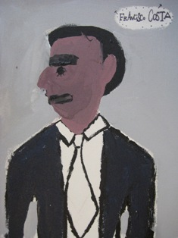
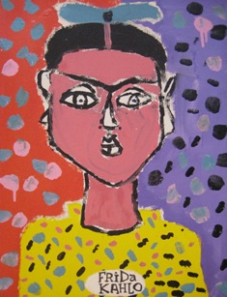
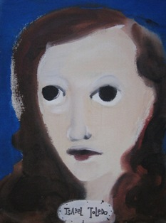
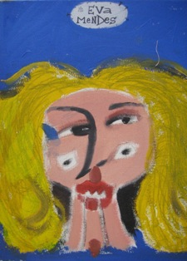
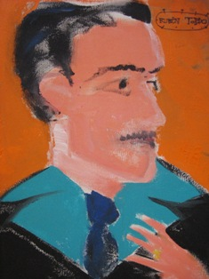
Children/Toledo portraits from left to right: Frieda Khalo, Ruben Toledo, Francisco Costa, Isabel Toledo, Eva Mendes

